



A Data-Driven Analysis of Unemployment and Its Determinants in Jordan (2014–2024)

Authors

Tala AlHanini , Majd AlQhwaje

Supervised by
Dr . Husam Barham

Course: 307498 – Graduation Project
Second Semester, 2025/2026

Date :8 . 6 . 2026



Abstract 7
Acknowledgment 8
Business Intelligence Project description and objectives 8
3.1 Business Intelligence Project Description 8
3.2 Project Objectives 9
3.3 Industry and Project Relevance 10
3.4 Business Questions Answered 10
3.5 Expected Impact 10
Data Research and Acquiring Effort 11
4.1 Data Search Strategy 11
4.2 Types of Data Searched 11
4.3 Data Selection Criteria 12
4.4 Data Acquisition Process 12
4.5 Importance of Reliable Data 12
Links to raw data 13
5.1 Raw Data Sources 13
5.2 Source Descriptions 13
5.3 Raw Data Accessibility 13
5.4 Importance of Using Official Sources 14
Data Description and understandings 14
6.1 Dataset Overview 14
6.2 Panel Data Structure 14
6.3 Dataset Variable Dictionary 15
6.4 Target Variable 16
6.5 Selected Regression Features 16
6.6 Clustering Features 17
6.7 Initial Data Understanding 17
Data Primary Cleaning and Transformation 18
7.1 Introduction 18
7.2 Data Cleaning Process 18
7.3 Column Renaming 18
7.4 Data Type Conversion 19
7.5 Handling Missing Values 19
7.6 Creating Additional Variables and Derived Indicators 20
7.7 Standardization for Clustering 21
7.8 Aggregation for Clustering 22
7.9 Exporting Cleaned Data and Outputs 22
7.10 Data Cleaning and Transformation Summary 22
8. Data Visualization and Insights 23
8.1 Introduction 23
8.2 Exploratory Data Analysis 23
8.3 Visualization Insights 23
9. Dashboard Design and Insights 24
9.1 Dashboard Overview 24
9.2 Dashboard 1: Labor Market Overview 24
9.3 Dashboard 1 Business Interpretation 26
9.4 Dashboard 2: Key Factors Affecting Unemployment 26
9.5 Dashboard 2 Business Interpretation 28
9.6 Difference Between Dashboard 1 and Dashboard 2 28
9.7 Dashboard Design Principles 29
9.8 Dashboard Insights Summary 29
10. Advanced Analytics and AI Modeling 30
10.1 Introduction 30
10.2 Why Statistical Modeling and Machine Learning Were Used 30
10.3 Python Libraries Used 31
10.4 Selected Regression Features 32
10.5 Variance Inflation Factor Analysis 32
10.6 Pooled OLS Regression 33
10.7 Pooled OLS Results and Interpretation 34
10.8 Fixed Effects Regression 35
10.9 Fixed Effects Results and Interpretation 36
10.10 Why Fixed Effects Was Better Than Pooled OLS? 39
10.11 Leave-One-Year-Out Validation 40
10.12 Overfitting Check 41
10.13 Residual Diagnostics 42
10.14 Performance Measurements 42
11. Clustering and PCA Analysis 43
11.1 Introduction 43
11.2 Clustering Features 43
11.3 K-Means Clustering 44
11.4 Elbow Method 44
11.5 Silhouette Score 45
11.6 PCA Role in Clustering 46
11.7 PCA Cluster Visualization 47
11.8 Hierarchical Clustering 48
11.9 Clustering Results Interpretation 49
12. Tools Research and Selection Effort 49
12.1 Introduction 49
12.2 Microsoft Excel 50
12.3 Python 50
12.4 Pandas and NumPy 51
12.5 Statsmodels 51
12.6 Scikit-learn 52
12.7 Matplotlib 52
12.8 Tableau 53
12.9 GitHub 53
12.10 Tools Summary 54
13. Project Deployment Effort – Use Case 54
13.2 Main Use Case 55
13.3 User Journey 55
13.4 Deployment Options 55
13.5 Project Flowchart 56
13.6 System Block Diagram 57
13.7 Deployment Benefits 57
14. Results 58
14.1 Introduction 58
14.2 Model Comparison Results 58
14.3 Pooled OLS Results 58
14.4 Fixed Effects Results 59
14.5 LOYO Validation Results 59
14.6 Clustering Results 59
14.7 Dashboard Results 60
14.8 Key Findings 60
14.9 Did the Project Achieve Its Objectives? 60
15. Conclusion and Recommendations 61
15.1 Conclusion 61
15.2 Recommendations 61
15.3 How the Situation Can Be Improved 62
15.4 Value of the Study 62
15.5 Future Work 63
16. References 63
17. Appendices 64
Appendix A: Important Python Code Sections 64
A.1 Importing Libraries 64
A.2 Project Settings 64
A.3 Regression Features 65
A.4 Clustering Features 65
A.5 RMSE Function 65
A.6 Model Summary Function 65
A.7 VIF Function 66
A.8 Loading and Cleaning Data 66
A.9 Handling Missing Values 66
A.10 Creating Year Squared 66
A.11 Pooled OLS Model 66
A.12 Fixed Effects Model 67
A.13 LOYO Validation 67
A.14 K-Means Clustering 67
A.15 PCA 67
A.16 Hierarchical Clustering 68
Closing Statement 68

Abstract
This graduation project presents a comprehensive data-driven analysis of unemployment in Jordan and its socioeconomic determinants during the period 2014–2024. Unemployment is one of the most critical economic challenges facing Jordan because it affects economic growth, labor market stability, social welfare, regional development, household income, and future employment opportunities. The project aims to analyze unemployment patterns across Jordanian governorates, identify the most influential socioeconomic factors, and provide decision-support insights using Business Intelligence, statistical modeling, and machine learning techniques.
The study uses panel data that combines governorate-level observations across multiple years. The dataset includes unemployment rate as the main target variable, along with several explanatory indicators such as population density, establishments per 1,000 people aged 15 and above, schools per 1,000 population, students per class, and student ratio for the 5–19 age group. The data was cleaned, standardized, and prepared using Python. The preprocessing stage included handling missing values, renaming variables, converting data types, selecting relevant features, checking multicollinearity using Variance Inflation Factor (VIF), and applying Principal Component Analysis (PCA) for dimensionality reduction and clustering visualization.
Several analytical techniques were applied in this project. Pooled Ordinary Least Squares (Pooled OLS) regression was used as a baseline model, while Fixed Effects regression was used as the main panel-data model to control for governorate-specific differences. Leave-One-Year-Out validation was applied to evaluate the model’s ability to generalize across time. In addition, K-Means clustering and Hierarchical Clustering were used to group Jordanian governorates according to socioeconomic similarity. Tableau dashboards were developed to visualize unemployment trends, compare governorates, and analyze the relationship between unemployment and key socioeconomic indicators.
The results showed that the Fixed Effects model achieved stronger predictive and explanatory performance than the Pooled OLS model, indicating the importance of considering governorate-specific characteristics when analyzing unemployment in Jordan. Clustering results revealed meaningful regional patterns, including the presence of distinct socioeconomic behavior among some governorates. The dashboards provided a clear visual interpretation of unemployment trends and key factors affecting the labor market. Overall, the project demonstrates how Business Intelligence, statistical modeling, and machine learning can be integrated to support labor market analysis and data-driven decision making in Jordan.
Keywords: Unemployment, Jordan, Panel Data, Fixed Effects, Pooled OLS, LOYO, VIF, PCA, K-Means, Hierarchical Clustering, Tableau, Business Intelligence, Machine Learning

Acknowledgment
We would like to express our sincere gratitude to our supervisor, Dr. Husam Barham, for his valuable guidance, continuous support, and constructive feedback throughout the development of this graduation project. His academic supervision helped us improve the quality of our research, analytical approach, implementation process, and final outcomes.
We also extend our appreciation to the University of Petra and the Faculty of Administration for providing us with the academic knowledge, learning environment, and practical skills required to complete this project successfully. Special thanks are also given to our families and friends for their encouragement, patience, and support during all stages of this work.
This project represents the outcome of continuous effort, teamwork, research, analysis, implementation, and learning. We are grateful to everyone who contributed directly or indirectly to the completion of this graduation project.

Business Intelligence Project description and objectives

3.1 Business Intelligence Project Description
This project is a Business Intelligence and data analytics project that focuses on analyzing unemployment in Jordan and identifying its socioeconomic determinants during the period 2014–2024. The project belongs to the economic and labor market analysis domain, where data-driven methods are used to support decision-making and improve understanding of national labor market challenges.
Unemployment is considered one of the most important economic indicators because it reflects the ability of the economy to create job opportunities and absorb the labor force. In Jordan, unemployment is affected by several interconnected factors, including population growth, regional economic differences, educational infrastructure, labor force participation, and the availability of economic establishments. Therefore, analyzing unemployment requires more than simple descriptive statistics; it requires a structured analytical approach that combines data preparation, statistical modeling, machine learning, and visualization.
The project uses a panel dataset that includes Jordanian governorates observed across multiple years. The dataset combines both time and regional dimensions, making it suitable for panel data analysis. The main dependent variable is the unemployment rate, while the independent variables include socioeconomic and educational indicators such as population density, establishments per 1,000 people aged 15 and above, schools per 1,000 population, students per class, and student ratio for the 5–19 age group.
The project applies several analytical methods. First, the data is cleaned and transformed using Python. Then, Variance Inflation Factor (VIF) is applied to check multicollinearity between independent variables. Regression models are then developed, including Pooled Ordinary Least Squares (Pooled OLS) and Fixed Effects regression. Fixed Effects regression is especially important because it controls governorate-specific characteristics that may affect unemployment but are not directly measured in the dataset.
In addition to regression modeling, the project applies clustering techniques to group Jordanian governorates according to socioeconomic similarity. K-Means clustering and Hierarchical Clustering are used for this purpose. Principal Component Analysis (PCA) is also applied to reduce dimensionality and visualize governorates in a two-dimensional space. Finally, Tableau dashboards are created to present the findings in an interactive and understandable way.
The Business Intelligence part of the project is represented through two Tableau dashboards. The first dashboard, “Labor Market Overview,” answers the question: what is happening in Jordan’s labor market? It visualizes unemployment trends, governorate-level differences, and general labor market patterns. The second dashboard, “Key Factors Affecting Unemployment,” answers the question: why is unemployment happening? It analyzes the relationship between unemployment and key socioeconomic indicators.
Overall, this project demonstrates how Business Intelligence, statistical modeling, and machine learning can be combined to analyze a real economic problem and provide useful insights for decision-makers, researchers, and public institutions.

3.2 Project Objectives
The main objective of this project is to analyze unemployment in Jordan using a data-driven approach and identify the socioeconomic factors that influence unemployment rates across governorates and years.
The specific objectives are:
- To collect and prepare unemployment-related data for Jordanian governorates between 2014 and 2024.
- To understand the structure of the dataset and identify the most relevant variables for unemployment analysis.
- To clean and transform the data using Python to make it suitable for statistical modeling and visualization.
- To use panel data analysis in order to study unemployment across both governorates and time.
- To apply Pooled OLS regression as a baseline statistical model.
- To apply Fixed Effects regression to control for governorate-specific differences.
- To evaluate model performance using R², RMSE, MAE, residual plots, and Leave-One-Year-Out validation.
- To use VIF analysis to detect multicollinearity between independent variables.
- To apply PCA for dimensionality reduction and clustering visualization.
- To apply K-Means and Hierarchical Clustering to classify governorates based on socioeconomic similarity.
- To build interactive Tableau dashboards that visualize unemployment trends and key influencing factors.
- To extract meaningful insights that can support economic planning and labor market decision-making.

3.3 Industry and Project Relevance
This project is related to the public sector, economic planning, labor market analysis, and Business Intelligence. The insights produced by the project can be useful for government institutions, economic researchers, policy makers, educational planners, and development organizations.
Government agencies may use the results to identify governorates with higher unemployment risk. Educational planners may use the findings to understand whether educational infrastructure is related to unemployment. Economic planners may use clustering results to compare governorates with similar socioeconomic conditions and design targeted interventions.
The project is also relevant to Business Intelligence because it transforms raw data into interactive dashboards and analytical insights. Instead of relying only on static tables, Tableau dashboards allow users to explore trends, compare governorates, filter by year, and understand relationships between variables.

3.4 Business Questions Answered
This project attempts to answer several business and analytical questions:
- How has unemployment changed in Jordan between 2014 and 2024?
- Which governorates show higher or lower unemployment rates?
- What socioeconomic indicators are associated with unemployment?
- Does population density influence unemployment patterns?
- Do economic establishments affect unemployment rates?
- Is educational infrastructure related to unemployment?
- Can governorates be grouped based on socioeconomic similarity?
- Which model provides better performance: Pooled OLS or Fixed Effects?
- Can interactive dashboards help decision-makers understand unemployment patterns more clearly?

3.5 Expected Impact
The expected impact of this project is to provide a clear analytical framework for understanding unemployment in Jordan. The project does not only present unemployment rates, but also explains the possible factors behind them using statistical models and visualization tools.
By combining Python and Tableau, the project supports both technical analysis and business communication. Python is used for preprocessing, modeling, validation, and clustering, while Tableau is used to communicate the findings visually through dashboards.
The final output helps transform unemployment data into actionable insights that can support better economic understanding and data-driven decision-making.

Data Research and Acquiring Effort

4.1 Data Search Strategy
This section describes the process followed to search for, evaluate, collect, and prepare the data used in this graduation project. Since the project focuses on unemployment in Jordan and its socioeconomic determinants, the data collection process required identifying official and reliable sources that provide labor market, population, education, and economic activity indicators at the governorate level.
The main purpose of the data research stage was to obtain a dataset that could support both descriptive Business Intelligence analysis and advanced statistical modeling. Therefore, the selected data needed to include unemployment rates as the main target variable, along with explanatory variables that may help explain unemployment differences across Jordanian governorates and years.
The data acquisition process focused on official Jordanian sources, including the Jordan Department of Statistics, the Social Security Corporation, and the Ministry of Education. These sources were selected because they provide reliable data related to labor market indicators, population statistics, education indicators, and establishments.

4.2 Types of Data Searched
During the search process, several types of data were considered. The first type was labor market data, including unemployment rate, employment rate, labor force, employed population, and unemployed population. These variables are directly related to the main objective of the project.
The second type was population-related data, including total population, population density, population aged 15 and above, and population aged 5–19. These variables were included because population structure may influence labor market pressure and unemployment patterns.
The third type was education-related data, including number of schools, number of students, number of classes, students per school, classes per school, students per class, schools per 1,000 population, and student ratio for the 5–19 age group. These indicators were important because education and labor market outcomes are often connected.
The fourth type was economic activity data, especially establishments per 1,000 people aged 15 and above. This variable was included as an indicator of economic activity and job creation potential.

4.3 Data Selection Criteria
The final dataset was selected based on several criteria:
- Relevance to unemployment analysis.
- Availability at governorate level.
- Availability across multiple years.
- Compatibility with panel data analysis.
- Reliability of the source.
- Suitability for regression, clustering, and visualization.
The dataset had to contain both governorate and year columns because the project uses a panel data structure. This structure allows the analysis to compare unemployment patterns across regions and across time.

4.4 Data Acquisition Process
After identifying the required variables, the data was collected, organized, and combined into a structured Excel file. The final Excel dataset served as the main input for the Python analysis pipeline. The data was then imported into Python using Pandas for cleaning, preprocessing, regression modeling, clustering, and output generation.
The cleaned and processed data was exported into several output files, including descriptive statistics, VIF results, model comparison results, clustering profiles, and visual figures. The same dataset was also used in Tableau to create the final Business Intelligence dashboards.

4.5 Importance of Reliable Data
The data research and acquisition stage was essential because the quality of any Business Intelligence or machine learning project depends heavily on the quality of the data. Reliable data sources, relevant variables, and a consistent structure helped ensure that the project results were meaningful and suitable for decision-making.
Inaccurate or incomplete data could lead to misleading model results, weak dashboards, and incorrect conclusions. Therefore, official and structured data sources were prioritized throughout the project

Links to raw data

5.1 Raw Data Sources
The raw data used in this project was collected from official and open-data sources. The main sources include:
- Jordan Department of Statistics.
- Social Security Corporation
- Ministry of Education.
- Structured Excel dataset prepared by the project team

5.2 Source Descriptions
The Jordan Department of Statistics (DOS) was the main source for labor market and population-related data. It provided official statistics related to unemployment rate, employment rate, labor force indicators, population distribution, and governorate-level demographic data. This source was essential because the project focuses on unemployment analysis across Jordanian governorates.
The Social Security Corporation (SSC) was used to obtain data related to the number of establishments. This data was important because establishments represent economic activity and job creation potential. The variable “Establishments per 1,000 people aged 15 and above” was used as one of the key socioeconomic indicators in the regression and dashboard analysis.
The Ministry of Education (MoE) was used to obtain education-related indicators, including the number of schools, number of students, number of classes, students per class, and schools per 1,000 population. These indicators were included because educational infrastructure and student distribution may be related to future labor market outcomes.
After collecting the data from these official sources, the project team organized and combined the variables into a structured Excel dataset. This dataset was then used in Python for data cleaning, statistical modeling, clustering analysis, and output generation. The same dataset was also used in Tableau to build the final dashboards.

5.3 Raw Data Accessibility
Google Drive Link: [Insert Google Drive Link Here]
GitHub Repository Link: [Insert GitHub Repository Link Here]
Jordan Department of Statistics Link: https://dosweb.dos.gov.jo/ar/
Social Security Corporation Link: https://www.ssc.gov.jo/
Ministry of Education Link: https://moe.gov.jo/ar/reports

5.4 Importance of Using Official Sources
Using official Jordanian sources improved the reliability and credibility of the project. Since the analysis focuses on unemployment and socioeconomic indicators at the governorate level, it was important to rely on institutions that publish national statistics and official administrative data.
The Jordan Department of Statistics supported the labor market and population analysis, the Social Security Corporation supported the economic establishments indicator, and the Ministry of Education supported the education-related indicators. Combining these sources allowed the project to build a richer dataset that connects unemployment with economic, demographic, and educational factors.

Data Description and understandings

6.1 Dataset Overview
The dataset used in this project is a panel dataset covering Jordanian governorates between 2014 and 2024. It includes unemployment rate as the main target variable and multiple socioeconomic indicators as explanatory variables.
The dataset structure supports both descriptive analysis and advanced modeling because each row represents a governorate-year observation. This means that each governorate appears across multiple years, allowing the project to analyze both regional and time-based changes.

6.2 Panel Data Structure
Panel data combines two dimensions:
- Cross-sectional dimension: different entities, such as governorates.
- Time-series dimension: repeated observations over time, such as years.
In this project, the cross-sectional units are Jordanian governorates, while the time dimension covers the years 2014 to 2024.

The general panel data structure can be represented as:
Governorate | Year | Unemployment Rate
Amman | 2014 | Values
Amman | 2015 | Values
Irbid | 2014 | Values
Irbid | 2015 | Values

Panel data is useful because it captures both changes over time and differences between governorates. This makes it stronger than a simple cross-sectional dataset or a simple time-series dataset.

6.3 Dataset Variable Dictionary
  - Table 6.1: Dataset Variables Dictionary
Variable | Description | Importance
Governorate | Name of the Jordanian governorate | Used as the regional unit of analysis
Year | Observation year | Used for time-based analysis
Unemployment Rate | Percentage of unemployed individuals | Main target variable
Employment Rate | Percentage of employed individuals | Labor market indicator
Establishments per 1,000 (15+) | Number of economic establishments per 1,000 people aged 15+ | Economic activity indicator
Num of Schools | Number of schools | Educational infrastructure indicator
Num of Students | Number of students | Education demand indicator
Number of Classes | Number of classrooms/classes | Education capacity indicator
Students per School | Average students per school | School capacity indicator
Classes per School | Average classes per school | School infrastructure indicator
Students per Class | Average number of students per class | Educational crowding indicator
Population 5–19 | Population in school-age group | Education-related demographic indicator
Student Ratio 5–19 | Student ratio in the 5–19 age group | Education participation indicator
Governorate | Name of the Jordanian governorate | Used as the regional unit of analysis
Year | Observation year | Used for time-based analysis
Unemployment Rate | Percentage of unemployed individuals | Main target variable
Employment Rate | Percentage of employed individuals | Labor market indicator
Establishments per 1,000 (15+) | Number of economic establishments per 1,000 people aged 15+ | Economic activity indicator

6.4 Target Variable
The target variable in this project is Unemployment Rate. It represents the percentage of unemployed individuals in the labor force. This variable was selected because it directly measures the labor market problem being analyzed.
Unemployment rate is influenced by several factors, including economic activity, population density, education, labor force participation, and regional development. Therefore, it is suitable for regression modeling and visualization.

6.5 Selected Regression Features
The final selected features used in regression modeling were:
- Establishments per 1,000 people aged 15 and above.
- Population Density.
- Schools per 1,000 population.
These variables were selected because they represent three important dimensions related to unemployment analysis: economic activity, demographic pressure, and educational infrastructure.
In addition, the selected variables were tested using the Variance Inflation Factor (VIF) to check for multicollinearity. The VIF results showed that these variables did not suffer from severe multicollinearity, meaning that they were suitable to be used together in the regression model.
This supports the reliability of the model because the independent variables were not highly overlapping in the information they provide. As a result, the regression coefficients can be interpreted more confidently.
  - Table 6.2: Selected Regression Features
Feature | Category | Reason for Selection
Establishments per 1,000 people aged 15+ | Economic activity | Represents business activity and potential job creation
Population Density | Demographic pressure | Represents population pressure on the labor market
Schools per 1,000 population | Educational infrastructure | Represents the availability of educational services relative to population size

6.6 Clustering Features
The clustering analysis used a wider set of variables because the goal was not prediction, but grouping governorates according to socioeconomic similarity.
The clustering features included:
- Unemployment Rate.
- Establishments per 1,000 people aged 15 and above.
- Population Density.
- Students per Class.
- Schools per 1,000 population.
- Student Ratio 5–19.
Including unemployment rate in clustering is acceptable because clustering is unsupervised analysis. In this context, unemployment rate was used as one socioeconomic characteristic among others, not as a prediction target.
  - Table 6.3: Clustering Features
Feature | Reason for Use in Clustering
Unemployment Rate | Represents labor market outcome
Establishments per 1,000 people aged 15+ | Represents economic activity
Population Density | Represents demographic pressure
Students per Class | Represents educational capacity
Schools per 1,000 Population | Represents education infrastructure
Student Ratio 5–19 | Represents educational participation

6.7 Initial Data Understanding
Initial exploration showed that unemployment patterns differ across governorates and years. Some governorates showed consistently higher unemployment rates, while others had more stable or lower values. The data also suggested that socioeconomic indicators such as population density and economic establishments vary significantly across governorates.
This variation supports the use of panel data models and clustering techniques. If all governorates behaved similarly, advanced modeling would not be necessary. However, the presence of differences between regions indicates that governorate-specific effects should be considered.

Data Primary Cleaning and Transformation

7.1 Introduction
After understanding the dataset structure, the next stage was data cleaning and transformation. This stage was necessary because raw data collected from different official sources may contain inconsistent column names, missing values, different formats, and variables with different scales. Before applying regression models, clustering techniques, or Tableau dashboards, the data had to be prepared in a clean and structured format.
The purpose of this stage was to transform the raw dataset into an analysis-ready panel dataset. Python was used as the main tool for cleaning, transformation, feature selection, validation, and exporting processed outputs

7.2 Data Cleaning Process
The data cleaning process included several steps. First, the Excel dataset was imported into Python from the selected worksheet. Then, the column names were standardized to make them easier to use in Python code. Some raw column names contained spaces, symbols, or inconsistent formatting, so they were renamed into clean variable names.
For example, variables such as “Unemployment Rate” and “Population Density” were renamed as Unemployment_Rate and Population_Density. This made the code easier to write, read, and debug.
The cleaning process also included removing extra spaces from governorate names and converting year values into numeric format. These steps helped ensure that the dataset could be grouped, filtered, and modeled correctly.

7.3 Column Renaming
Column renaming was one of the first cleaning steps. The raw dataset contained column names with spaces and different formats. To avoid coding errors, a renaming map was created in Python.
Example code:
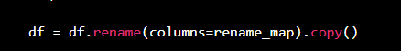

This code replaces the original column names with standardized names. Standardized names are important because they allow variables to be used easily in regression formulas and clustering functions.
Examples of renamed variables include:
Original Column Name | Cleaned Column Name
Governorates | Governorate
YEAR | Year
Unemployment Rate | Unemployment_Rate
Population Density | Population_Density
Schools per 1,000 population | Schools_per_1000_population
Establishments per 1,000 (15+) | Establishments_per_1000_15plus
Students per Class | Students_per_Class

7.4 Data Type Conversion
After renaming the columns, numeric variables were converted into numeric data types. This step was important because some values may be imported from Excel as text, even if they represent numbers.
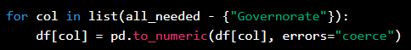
This code converts selected columns into numeric values. If a value cannot be converted, it is treated as missing. This makes the dataset safer for mathematical operations, regression analysis, and clustering.

7.5 Handling Missing Values
Missing values can affect the reliability of statistical models and machine learning algorithms. Therefore, rows with missing values in essential columns were removed from the modeling dataset.
Example code:
df = df.dropna(subset=["Governorate", "Year", TARGET] + BASE_FEATURES).reset_index(drop=True)
This line removes any row that has missing values in the governorate, year, target variable, or selected regression features. This was necessary because the regression models require complete observations for the selected variables.
The project did not remove data randomly. Only observations missing essential modeling variables were removed to ensure model stability and valid results

7.6 Creating Additional Variables and Derived Indicators
A very important part of the data preparation stage was the creation of derived variables. Some required indicators were not directly available in the raw data, so they had to be calculated using formulas. This was especially important for the years 2014 to 2016.
For the years 2014–2016, the dataset did not provide the actual number of population by some age categories. Instead, the available data provided population rates or percentages. Therefore, the project team calculated the actual population values using the total population and the available percentage rate.
For example, the population aged 15 and above was calculated using the following Excel formula:
=Table3[@[Total Population]]*(Table3[@[population +15 Rate]]/100)
This formula means that the total population was multiplied by the population rate aged 15 and above divided by 100. This allowed the project team to estimate the actual number of people aged 15 and above for the years where only percentages were available.
In addition to population calculations, several other derived indicators were created to make the dataset more useful for analysis and modeling. These calculated indicators helped convert raw counts into meaningful ratios that can be compared across governorates with different population sizes.
The main derived indicators included:
- Population aged 15 and above
This was calculated from total population and the percentage of population aged 15 and above, especially for years where the actual number was not directly available.
- Population Density
Population density was calculated using total population and area. This variable represents the number of people per unit of area and was used as a demographic pressure indicator.
- Schools per 1,000 Population
This was calculated to measure the availability of schools relative to the population size. It helps compare educational infrastructure between governorates fairly.
- Students per School
This indicator was calculated by dividing the number of students by the number of schools. It measures the average student load per school.
- Students per Class
This indicator was calculated by dividing the number of students by the number of classes. It represents classroom density and educational capacity pressure.
- Classes per School
This indicator was calculated by dividing the number of classes by the number of schools. It provides an overview of school capacity and infrastructure.
- Establishments per 1,000 people aged 15 and above
This indicator was calculated using the number of establishments and the population aged 15 and above. It was used as an economic activity indicator because establishments represent business activity and potential job opportunities.
- Labor Force-related indicators
Labor force indicators were calculated and used to describe the economically active population. These indicators helped support the labor market analysis and understand the relationship between employment, unemployment, and the active working population.
- Economic Activity / Economic Strength Indicator
The establishments-related ratio was used as a proxy for economic strength or economic activity. A higher ratio may indicate stronger business presence and more potential employment opportunities.
These derived variables were important because raw numbers alone can be misleading when comparing governorates. For example, a governorate with a larger population may naturally have more schools or establishments, but this does not necessarily mean it has better services or stronger economic activity. Ratios such as schools per 1,000 population and establishments per 1,000 people aged 15 and above allow fairer comparison between governorates.
A new variable called Year_Squared was also created to capture possible nonlinear time trends. This variable was especially useful in the Leave-One-Year-Out validation specification.
Example code:
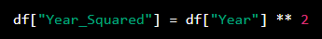
The purpose of this variable was to allow the model to capture more complex patterns over time instead of assuming that the effect of year is always linear.

7.7 Standardization for Clustering
Before applying clustering techniques, the clustering variables were standardized using StandardScaler. This step was necessary because clustering algorithms such as K-Means depend on distances between observations.
If variables have different scales, variables with larger numeric ranges may dominate the clustering results. For example, population density may have much larger values than unemployment rate. Standardization solves this issue by converting all variables into a comparable scale.
Example code: 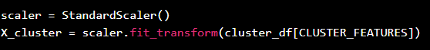
After standardization, each variable has a mean close to 0 and a standard deviation close to 1. This makes the clustering process fairer and more reliable.

7.8 Aggregation for Clustering
For clustering analysis, the data was aggregated by governorate. The average value of each clustering feature was calculated for every governorate.
Example code:
cluster_df = df.groupby("Governorate")[CLUSTER_FEATURES].mean().reset_index()
This step was important because clustering was used to group governorates based on their overall socioeconomic profile, not based on each year separately. By calculating governorate averages, each governorate became one observation in the clustering dataset

7.9 Exporting Cleaned Data and Outputs
After cleaning and transformation, the cleaned panel dataset was exported into an Excel file. The Python code also exported several output files such as descriptive statistics, VIF results, model comparison, clustering profiles, and generated figures.
Example output files include:
- cleaned_panel_data.xlsx
- descriptive_statistics.xlsx
- vif_results.xlsx
- model_comparison.xlsx
- leave_one_year_out_results.xlsx
- cluster_profiles.xlsx
- governorates_with_clusters.xlsx
Exporting these outputs made the project more organized and reproducible. It also allowed the results to be used in the report, presentation, and Tableau dashboards.

7.10 Data Cleaning and Transformation Summary
  - Table 7.1: Data Cleaning and Transformation Steps
Step | Description | Purpose
Data loading | Imported the Excel dataset into Python | Prepare data for analysis
Column renaming | Standardized variable names | Reduce coding errors
Data type conversion | Converted variables into numeric format | Enable modeling and calculations
Missing value handling | Removed rows missing essential variables | Improve model reliability
Feature selection | Selected relevant regression variables | Improve interpretability
Year squared creation | Created nonlinear time variable | Capture time trend patterns
Standardization | Scaled clustering variables | Improve clustering reliability
Aggregation | Averaged clustering variables by governorate | Build governorate-level clustering dataset
Exporting outputs | Saved cleaned files and results | Support reporting and reproducibility

8. Data Visualization and Insights

8.1 Introduction
After cleaning and preparing the dataset, visualization was used to explore unemployment patterns and communicate insights clearly. Data visualization is an essential part of Business Intelligence because it transforms numerical data into visual patterns that can be understood by both technical and non-technical users.
In this project, visualization was used for two main purposes. First, it supported exploratory data analysis by helping identify trends, relationships, and differences between governorates. Second, it supported the final dashboard design in Tableau.

8.2 Exploratory Data Analysis
Exploratory Data Analysis, or EDA, was performed to understand the data before modeling. The goal was to identify patterns and relationships between unemployment and socioeconomic variables.
The EDA process focused on answering questions such as:
- How did unemployment change between 2014 and 2024?
- Which governorates had higher unemployment rates?
- Are economic establishments related to unemployment?
- Is population density associated with unemployment?
- Do education indicators show a relationship with unemployment?
EDA helped guide the selection of variables and supported the interpretation of the final models.

8.3 Visualization Insights
Initial visual exploration showed that unemployment rates varied across governorates and years. This confirmed that unemployment in Jordan is not a uniform national issue, but a regional issue with different patterns across governorates.
The visual analysis also suggested that socioeconomic variables such as establishments, population density, and education indicators may be related to unemployment. These observations supported the use of regression modeling and clustering techniques.

9. Dashboard Design and Insights

9.1 Dashboard Overview
After completing the data cleaning and exploratory analysis stages, Tableau was used to build interactive Business Intelligence dashboards. The purpose of the dashboards was to transform the analytical dataset into clear visual insights that can be understood by both technical and non-technical users.
The project includes two main dashboards:
- Labor Market Overview Dashboard
- Key Factors Affecting Unemployment Dashboard
The dashboards were designed to answer two different but connected analytical questions. The first dashboard answers the question “What is happening?” by showing unemployment trends and governorate-level differences. The second dashboard answers the question “Why is it happening?” by visualizing the relationship between unemployment and selected socioeconomic indicators.
This separation makes the dashboard design more organized. Instead of presenting all charts in one overcrowded dashboard, the project divides the analysis into an overview dashboard and an explanatory dashboard

9.2 Dashboard 1: Labor Market Overview
The first dashboard is titled Labor Market Overview. It provides a general understanding of unemployment patterns in Jordan between 2014 and 2024. This dashboard is designed as an overview page that allows users to quickly identify national trends, governorate differences, and important labor market changes.
The dashboard includes:
- Unemployment trend over time.
- Governorate-level unemployment comparison.
- Geographic visualization using a map.
- Employment and unemployment profile comparison.
- Interactive filters for year and governorate.
- Summary indicators that highlight important values.
This dashboard helps users answer the following questions:
- How did unemployment change from 2014 to 2024?
- Which governorates had higher unemployment levels?
- Is unemployment distributed equally across Jordan?
- What year showed the highest unemployment level?
- How do governorates compare in employment and unemployment indicators?
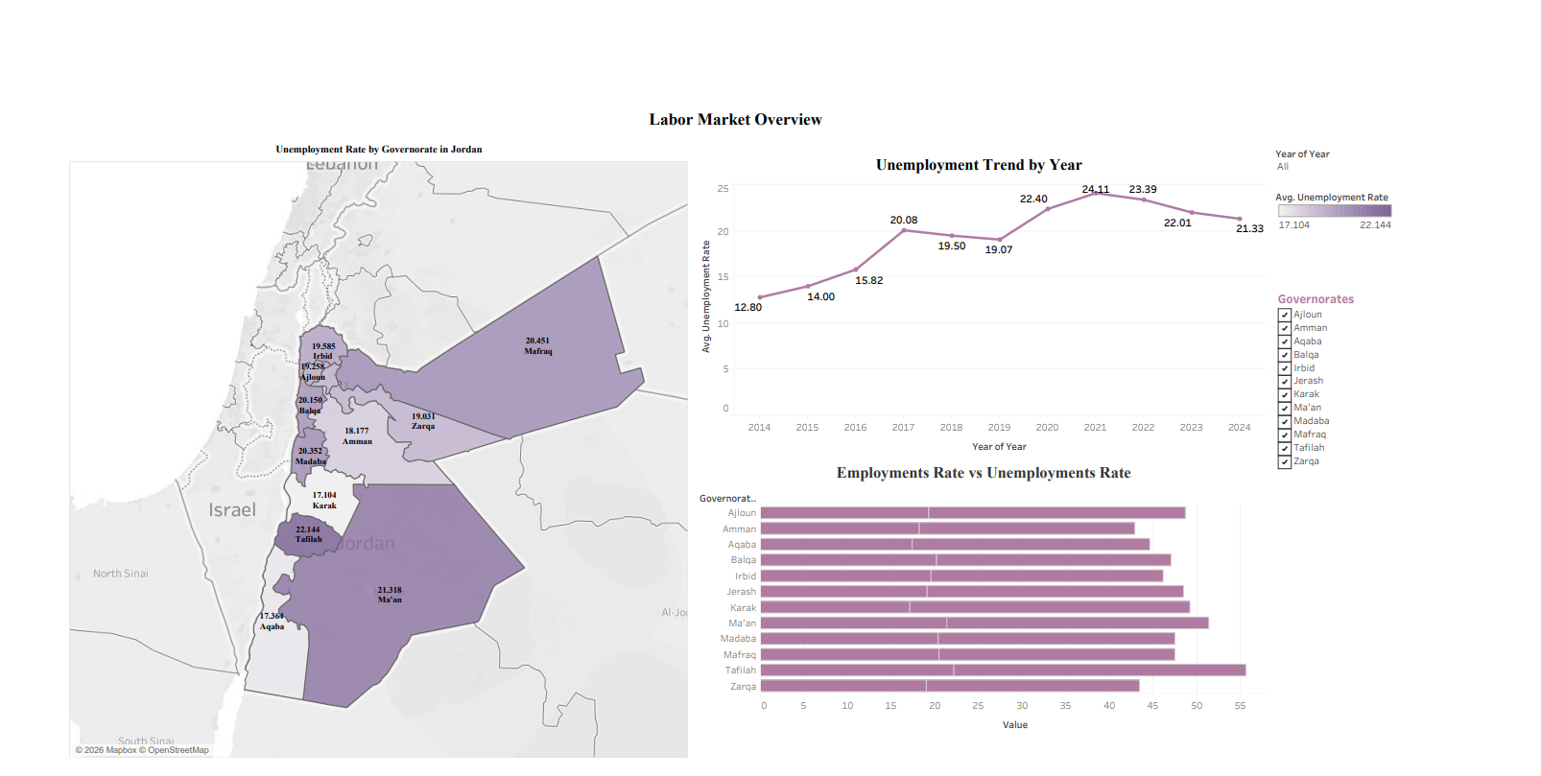

As shown in Figure 9.1, the Labor Market Overview dashboard presents the overall unemployment situation in a clear visual format.
  - Figure 9.1: Labor Market Overview Dashboard
The main insight from this dashboard is that unemployment in Jordan is not distributed equally across governorates. Some governorates show higher unemployment levels than others, and unemployment also changes over time. This confirms that unemployment is both a time-based and regional issue.
The dashboard also shows that unemployment increased noticeably after 2016 and reached a peak around 2021. This pattern may reflect changes in economic conditions, labor market pressure, and external factors affecting the Jordanian economy.
The map visualization is important because it allows users to see spatial differences between governorates. This helps decision-makers identify areas that may require more attention, targeted employment programs, or economic development initiatives.

9.3 Dashboard 1 Business Interpretation
The Labor Market Overview dashboard provides the first layer of analysis. It does not try to explain every reason behind unemployment, but it helps users understand the general situation.
The dashboard supports the following business interpretation:
- Unemployment is not a uniform national issue.
- Governorates differ in unemployment levels.
- Yearly changes suggest that unemployment is affected by time-related economic conditions.
- Regional comparison is necessary for better labor market planning.
- Policy decisions should consider governorate-level differences.
This dashboard is useful for government institutions, researchers, and economic planners because it provides a quick summary of labor market conditions in Jordan.

9.4 Dashboard 2: Key Factors Affecting Unemployment
The second dashboard is titled Key Factors Affecting Unemployment. While the first dashboard focuses on what is happening, this dashboard focuses on possible explanations behind unemployment patterns.
The dashboard includes visual relationships between unemployment and selected socioeconomic indicators. These indicators include:
- Establishments per 1,000 people aged 15 and above.
- Population Density.
- Schools per 1,000 population.
- Regression coefficient visualization.

The dashboard uses scatter plots and trend lines to show descriptive relationships between variables. It also includes coefficient-based interpretation from the statistical modeling stage.

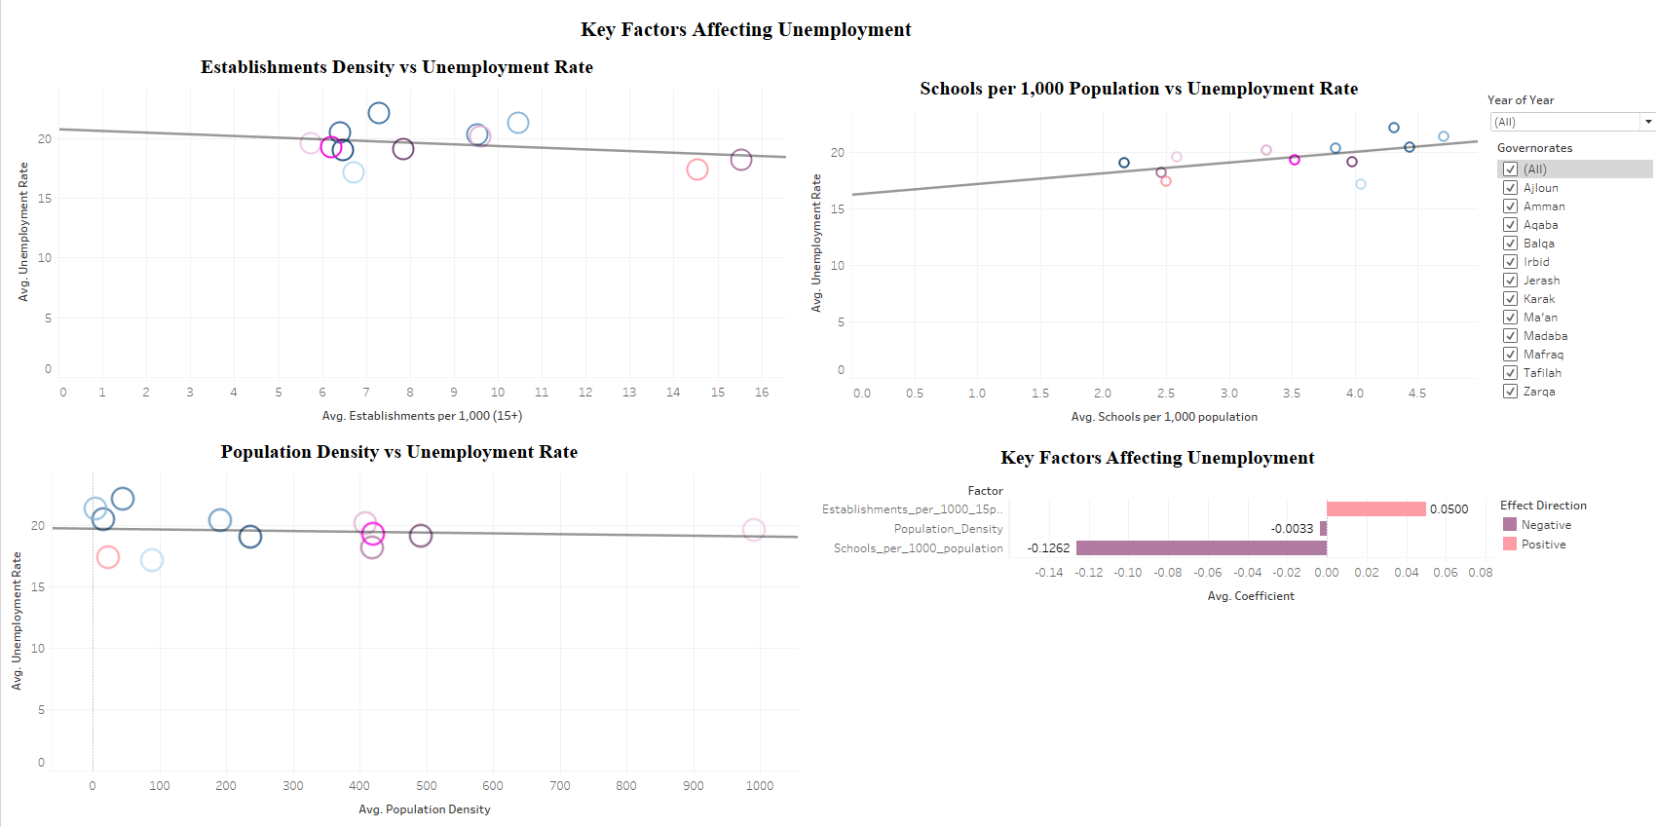
As shown in Figure 9.2, the Key Factors Affecting Unemployment dashboard links unemployment with socioeconomic determinants.

  - Figure 9.2: Key Factors Affecting Unemployment Dashboard
This dashboard helps users answer the following questions:
- How is unemployment related to economic establishments?
- Is population density associated with unemployment?
- Do education indicators show a relationship with unemployment?
- Which variables have stronger model-based coefficients?
- How can socioeconomic indicators help explain unemployment differences?

9.5 Dashboard 2 Business Interpretation
The Key Factors Affecting Unemployment dashboard provides a deeper analytical layer. It helps explain why unemployment may differ between governorates by visualizing its relationship with socioeconomic indicators.
The dashboard shows that unemployment is not affected by one factor only. Instead, it is connected to a combination of economic, demographic, and educational indicators.
The establishments indicator represents economic activity and potential job creation. A higher number of establishments may suggest a stronger local economy and more employment opportunities.
Population density represents demographic pressure. High population density can increase competition for jobs, especially if job creation does not grow at the same pace.
Schools per 1,000 population represents educational infrastructure. This indicator may be related to long-term labor market outcomes because education affects skills, employability, and human capital development.
The coefficient chart supports model-based interpretation. Scatter plots are descriptive and show simple visual relationships, while coefficients provide statistical evidence after controlling for other variables in the model.

9.6 Difference Between Dashboard 1 and Dashboard 2
The two dashboards have different roles in the project.
Table 9.1: Dashboard Business Questions
Dashboard | Main Question | Purpose
Labor Market Overview | What is happening? | Shows unemployment trends, maps, and governorate comparison
Key Factors Affecting Unemployment | Why is it happening? | Explains relationships between unemployment and socioeconomic factors
The first dashboard is descriptive. It provides a general overview of unemployment. The second dashboard is analytical. It explains possible factors associated with unemployment.
Together, the dashboards create a complete Business Intelligence story. The user first understands the unemployment problem visually, then explores the socioeconomic indicators that may explain it.

9.7 Dashboard Design Principles
The dashboards were designed using Business Intelligence principles. The main goal was to create dashboards that are clear, interactive, and useful for decision-making.
The design principles included:
- Clear dashboard titles
Each dashboard has a clear title that explains its purpose.
- Interactive filters
Filters allow users to explore specific years or governorates.
- Visual hierarchy
Important charts and values are placed in visible areas to guide user attention.
- Readable charts
Charts were designed to be simple and understandable.
- Consistent visual style
The dashboards use consistent formatting and layout.
- Analytical storytelling
The dashboards are organized to tell a story from general overview to detailed factors.
- Decision-support focus
The dashboards are designed to support interpretation and decision-making, not only display data.

9.8 Dashboard Insights Summary
The dashboards produced several important insights:
- Unemployment differs across Jordanian governorates.
- The unemployment trend changed significantly during the study period.
- Some years showed higher unemployment levels than others.
- Economic establishments, population density, and education indicators are relevant to unemployment analysis.
- Dashboard visualization makes unemployment patterns easier to understand.
- The dashboards support both descriptive and analytical interpretation.
These insights helped connect the Business Intelligence part of the project with the statistical modeling and clustering results.

10. Advanced Analytics and AI Modeling

10.1 Introduction
This section presents the advanced analytics and machine learning modeling part of the project. After completing data collection, cleaning, preparation, and visualization, the next step was to apply statistical and machine learning techniques to understand unemployment patterns in Jordan and identify the socioeconomic determinants that affect unemployment rates across governorates and years.
The project does not depend on one simple model only. Instead, it uses a complete analytical pipeline that includes baseline regression, panel-data modeling, validation, multicollinearity testing, residual diagnostics, clustering, and dimensionality reduction.
The advanced analytics part includes the following techniques:
- Pooled Ordinary Least Squares Regression.
- Fixed Effects Regression.
- Leave-One-Year-Out Validation.
- Variance Inflation Factor.
- Residual Diagnostics.
- Principal Component Analysis.
- K-Means Clustering.
- Hierarchical Clustering.
The main goal of the modeling phase is not only to predict unemployment, but also to explain how socioeconomic indicators are related to unemployment and how governorates can be grouped according to similarity.

10.2 Why Statistical Modeling and Machine Learning Were Used
Unemployment is a complex economic issue affected by many factors. Simple tables or charts can show unemployment rates, but they cannot fully explain relationships between variables. For this reason, statistical modeling and machine learning methods were applied.
Statistical modeling was used to estimate the relationship between unemployment rate and selected explanatory variables. Machine learning techniques were used to group governorates and discover hidden patterns in the dataset. Business Intelligence dashboards were then used to communicate the findings visually.

  - Table 10.1: Analytical Methods and Their Purpose
Method | Main Question Answered
Descriptive analysis | What is happening?
Regression modeling | Which factors are related to unemployment?
Fixed Effects | How do governorate differences affect unemployment?
LOYO validation | Can the model generalize across years?
Clustering | Which governorates are similar?
PCA | How can multidimensional data be visualized clearly?
Tableau dashboards | How can insights be communicated to users?
This combination supports both technical analysis and business decision-making.

10.3 Python Libraries Used
The AI and analytics implementation was completed using Python because it provides strong libraries for data science, statistics, machine learning, and visualization.
Table 10.2: Python Libraries Used in the Project
Library | Purpose in the Project
Pandas | Loading Excel data, cleaning, transformation, grouping, exporting results
NumPy | Numerical operations and array calculations
Matplotlib | Creating regression and clustering figures
Statsmodels | Running Pooled OLS, Fixed Effects, and statistical diagnostics
Scikit-learn | Scaling, PCA, K-Means, silhouette score, and evaluation metrics
SciPy | Hierarchical clustering and dendrogram generation
OpenPyXL | Reading and writing Excel files
These libraries were selected because they are widely used in data analytics and academic research. Statsmodels was especially important because it provides statistical outputs such as coefficients, p-values, standard errors, confidence intervals, and robust covariance estimators.

10.4 Selected Regression Features
The final regression model used three main explanatory variables:
- Establishments per 1,000 people aged 15 and above.
- Population Density.
- Schools per 1,000 population.
These variables were selected because they represent three important dimensions of unemployment analysis:
- Economic activity.
- Demographic pressure.
- Educational infrastructure.
In addition, the selected variables were tested using the Variance Inflation Factor (VIF). The VIF results showed that the selected variables did not suffer from severe multicollinearity, meaning that they were suitable to be used together in the regression model.
  - Table 10.3: Selected Regression Features
Feature | Type | Reason for Selection
Establishments per 1,000 people aged 15+ | Economic indicator | Represents business activity and potential job creation
Population Density | Demographic indicator | Represents population pressure on the labor market
Schools per 1,000 population | Education indicator | Represents availability of educational infrastructure
The unemployment rate was used as the target variable. The objective was to estimate how these variables are associated with unemployment across governorates and years.

10.5 Variance Inflation Factor Analysis
Variance Inflation Factor was used to check multicollinearity between independent variables. Multicollinearity occurs when two or more independent variables are highly correlated with each other.
High multicollinearity can make regression coefficients unstable and difficult to interpret. Therefore, VIF was applied before finalizing the regression model.
The VIF equation is:
VIFᵢ = 1 / (1 − Rᵢ²)
Where:
Symbol | Meaning
VIFᵢ | Variance Inflation Factor for variable i
Rᵢ² | R-squared from regressing variable i on the other independent variables
  - Table 10.4: VIF Interpretation Rules
VIF Value | Interpretation
1 | No multicollinearity
1–5 | Acceptable level
5–10 | Moderate to high multicollinearity
Greater than 10 | Severe multicollinearity
The VIF results supported using the selected regression variables because they did not show severe multicollinearity. This improved the reliability of the regression model and made coefficient interpretation more stable.

10.6 Pooled OLS Regression
Pooled Ordinary Least Squares was used as the baseline regression model. It combines all observations into one dataset and estimates one general relationship between unemployment and the selected explanatory variables.
The general equation is:
Yit = β0 + β1X1it + β2X2it + β3X3it + εit
Where:
Symbol | Meaning
Yit | Unemployment rate for governorate i in year t
β0 | Intercept
X1it | Establishments per 1,000 people aged 15+
X2it | Population Density
X3it | Schools per 1,000 population
β1, β2, β3 | Regression coefficients
εit | Error term
Pooled OLS is useful because it gives a simple benchmark model. However, it has an important limitation: it does not fully account for differences between governorates. For example, Amman, Aqaba, Irbid, and Ma’an may have different economic structures, labor markets, infrastructure, and demographic conditions. Treating all governorates as identical may reduce the model’s ability to explain unemployment.

10.7 Pooled OLS Results and Interpretation
The Pooled OLS model achieved the following performance:
  - Table 10.5: Pooled OLS Performance Results
Metric | Value | Interpretation
R² | 0.281 | The model explains around 28.1% of unemployment variation
RMSE | 3.586 | Average prediction error magnitude is relatively high
MAE | 2.955 | Average absolute prediction error is around 2.955 percentage points
These results show that Pooled OLS captured some general unemployment patterns, but its explanatory power was limited. This is expected because Pooled OLS does not control for governorate-specific characteristics.
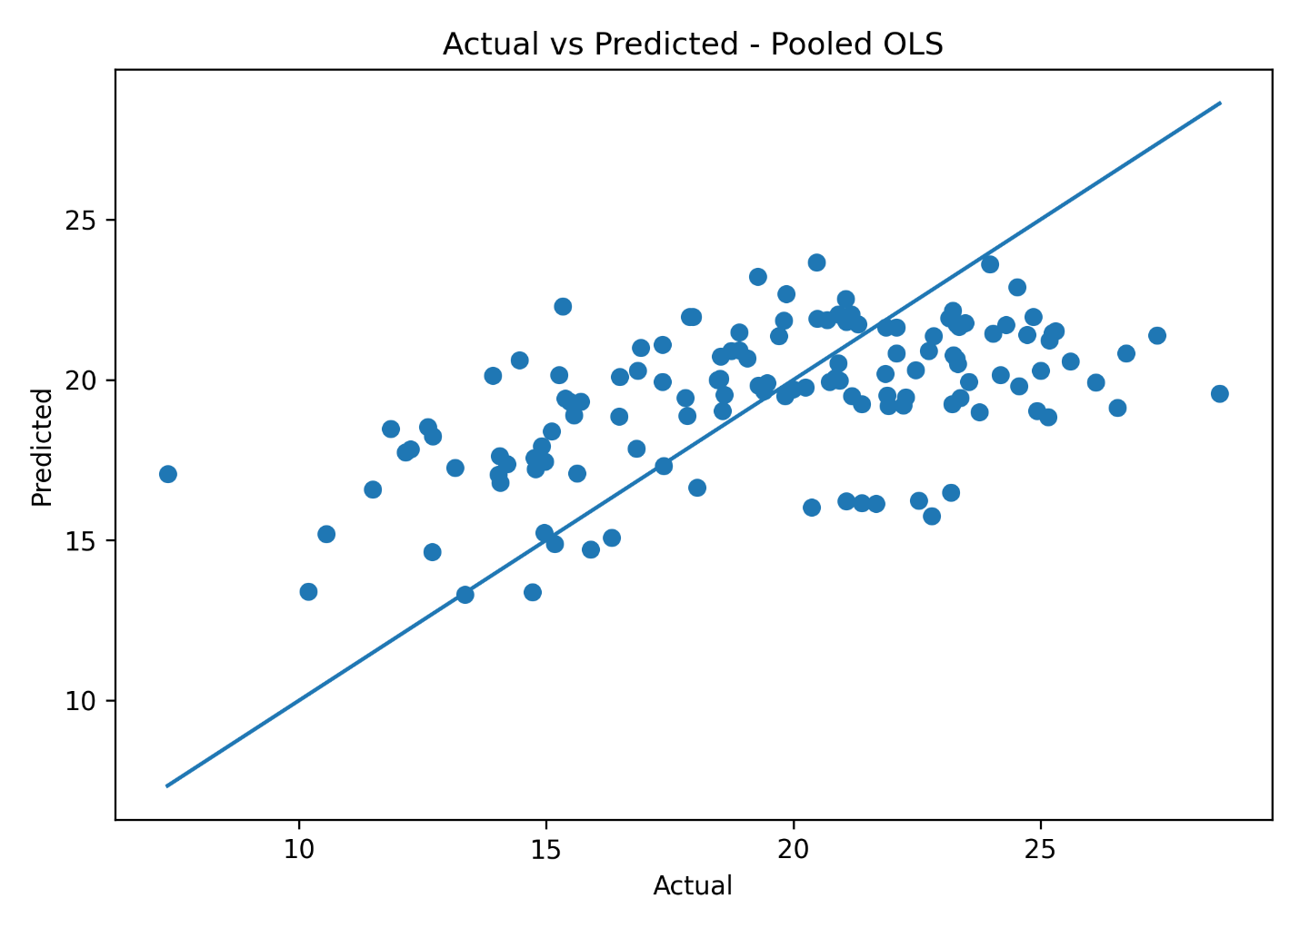
  - Figure 10.1: Actual vs Predicted Values for Pooled OLS Model
As shown in Figure 10.1, the Pooled OLS predictions do not perfectly align with the actual unemployment values. Points that are far from the diagonal line indicate prediction errors.
  - Figure 10.2: Residuals Plot for Pooled OLS Model
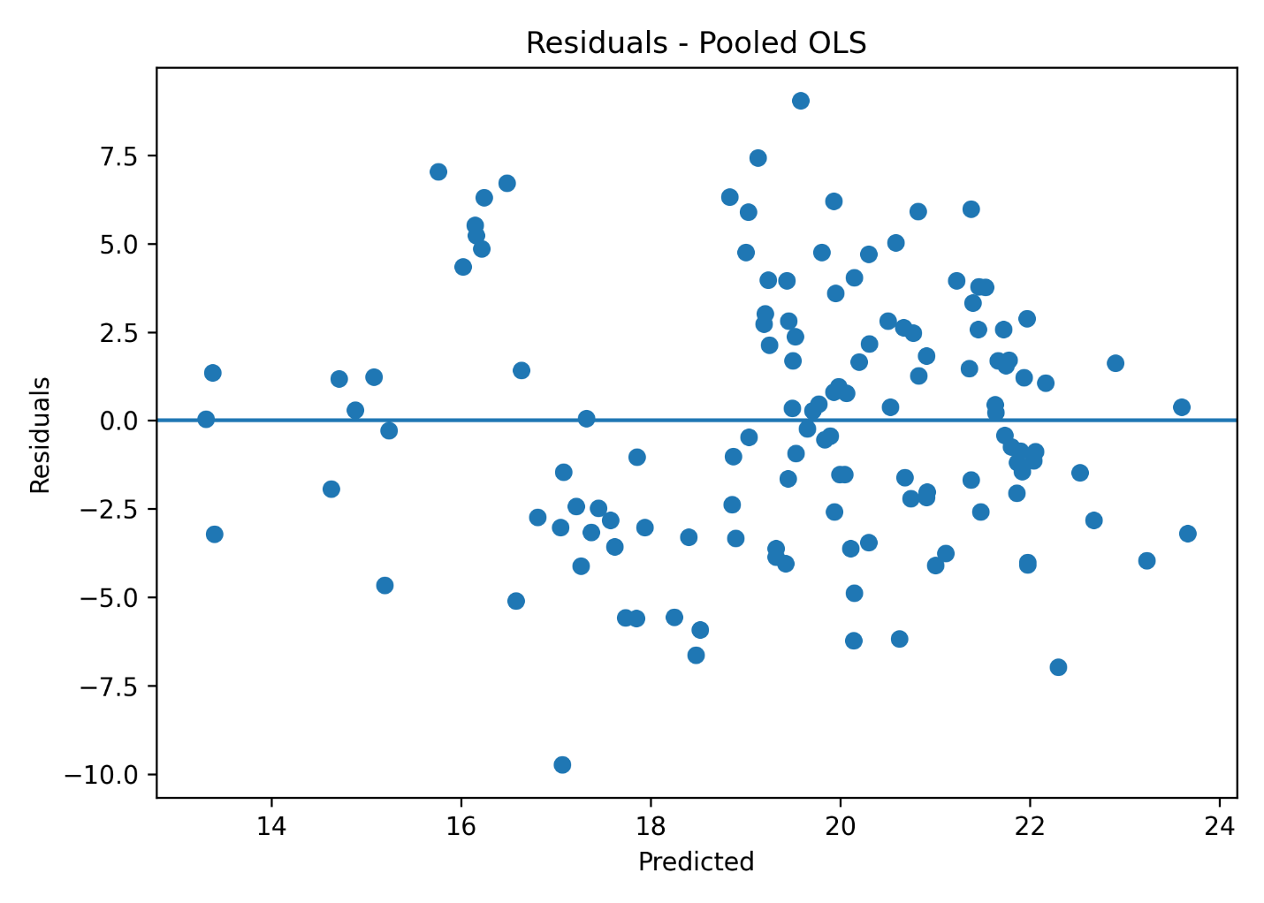
Figure 10.2 shows the residual distribution for the Pooled OLS model. Residuals represent the difference between actual and predicted unemployment values. A good regression model should have residuals distributed randomly around zero.

10.8 Fixed Effects Regression
The Fixed Effects model was used as the main regression model because the dataset is panel data. Panel data includes repeated observations for the same governorates over multiple years. This structure requires a model that can account for differences between governorates.
The Fixed Effects equation is:
Yit = αi + β1X1it + β2X2it + β3X3it + εit
Where:
Symbol | Meaning
Yit | Unemployment rate for governorate i in year t
αi | Governorate-specific fixed effect
X variables | Socioeconomic indicators
β coefficients | Estimated effects of explanatory variables
εit | Error term
The most important part of the equation is αi, which represents the specific effect of each governorate. This allows the model to capture unobserved characteristics that differ between governorates but remain relatively stable over time.
Examples of governorate-specific characteristics include geographic location, local economic structure, infrastructure, investment activity, labor market conditions, educational environment, and population structure.
Fixed Effects was selected because it is more suitable than Pooled OLS for analyzing unemployment across governorates and years.

10.9 Fixed Effects Results and Interpretation
The Fixed Effects model achieved the following results:
Table 10.6: Fixed Effects Performance Results
Metric | Value | Interpretation
R² | 0.847 | The model explains around 84.7% of unemployment variation
RMSE | 1.657 | Prediction error is lower than Pooled OLS
MAE | 1.306 | Average absolute prediction error is lower than Pooled OLS
The Fixed Effects model performed significantly better than the Pooled OLS model. This indicates that governorate-specific differences are very important when analyzing unemployment in Jordan.
  - Figure 10.3: Actual vs Predicted Values for Fixed Effects Model
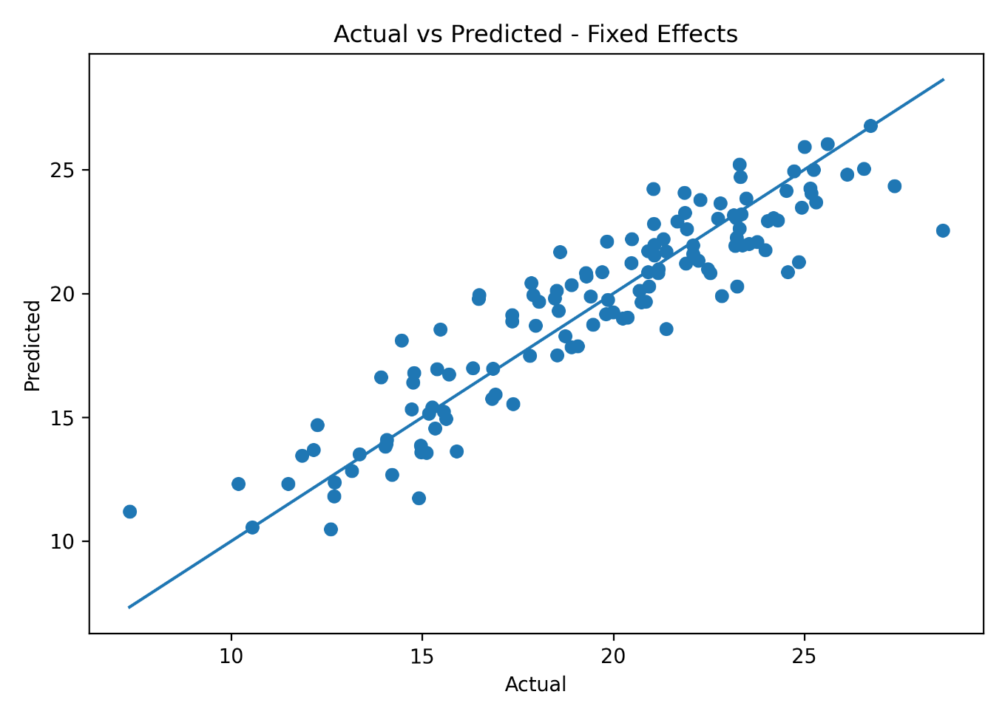
As shown in Figure 10.3, the predicted values from the Fixed Effects model are closer to the actual values compared to Pooled OLS. This demonstrates improved predictive accuracy.

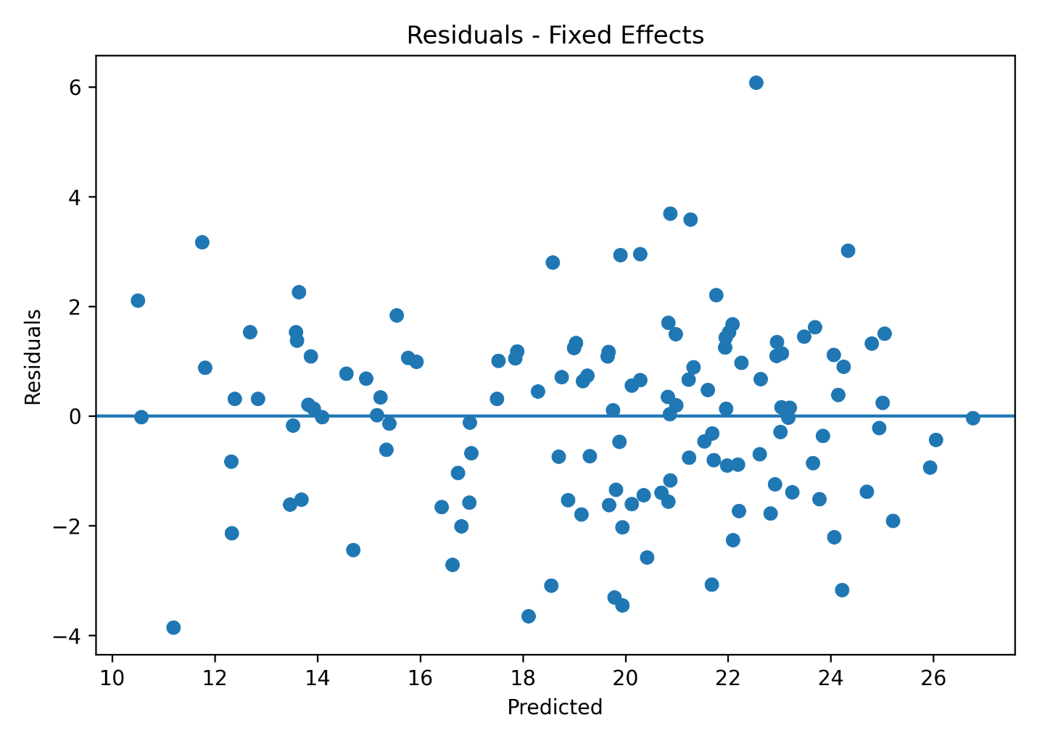
  - Figure 10.4: Residuals Plot for Fixed Effects Model
Figure 10.4 presents the residuals of the Fixed Effects model. The residuals are smaller and more balanced compared to the baseline model, which supports the improvement in model performance.

  - Figure 10.5: Fixed Effects Base Variable Coefficients
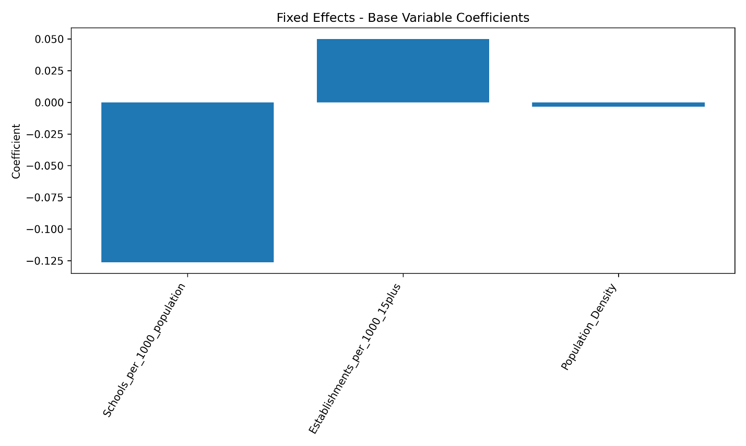
Figure 10.5 shows the coefficients of the selected explanatory variables. Coefficients help interpret the direction and strength of the relationship between each variable and unemployment.

10.10 Why Fixed Effects Was Better Than Pooled OLS?
The improvement in Fixed Effects performance can be explained by the nature of the data. Since the dataset includes governorates observed across several years, it contains both regional and time-based variation.
Pooled OLS assumes that all governorates share the same general structure. However, this assumption is too simple for a country-level labor market analysis. Governorates differ in population size, economic activity, infrastructure, education, investment, and job opportunities.
Fixed Effects solves this issue by allowing each governorate to have its own baseline effect. This improves the model’s ability to explain unemployment patterns.
The comparison clearly shows that:
- Pooled OLS is useful as a baseline.
- Fixed Effects is more suitable for panel data.
- Governorate-specific effects are important.
- Regional differences must be considered in unemployment analysis.

10.11 Leave-One-Year-Out Validation
Leave-One-Year-Out Validation, abbreviated as LOYO, was used to evaluate how well the model performs on unseen years.
The process works as follows:
- Select one year as the test year.
- Remove that year from the training dataset.
- Train the model on all remaining years.
- Predict unemployment for the excluded year.
- Repeat the process for every year.
- Combine all predictions and evaluate overall performance.
This validation method is important because unemployment may change from year to year due to economic shocks, government policies, demographic changes, and external conditions.
LOYO is stronger than only reporting in-sample performance because it tests whether the model can generalize across time.
Figure 10.6: Actual vs Predicted Values for Leave-One-Year-Out Validation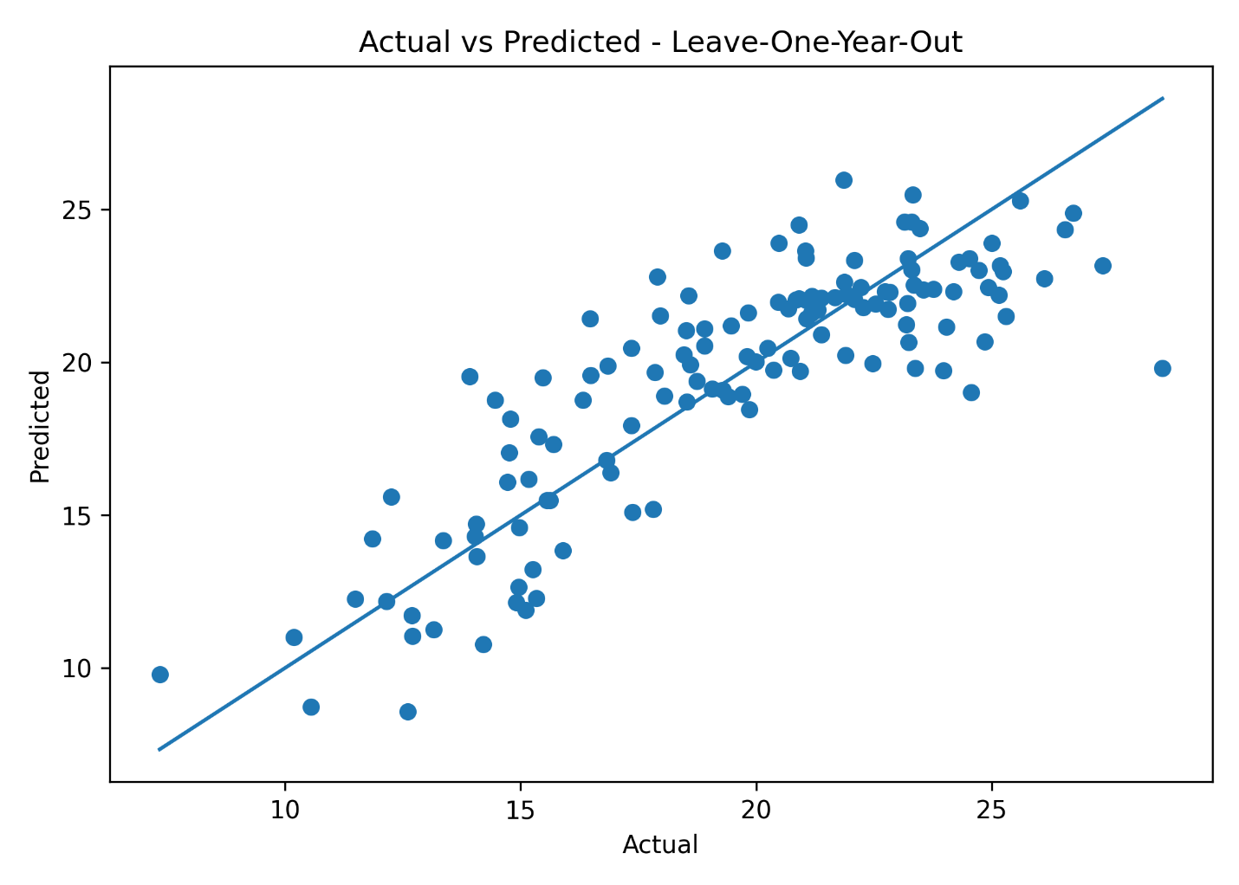
Figure 10.6 shows the actual and predicted values for Leave-One-Year-Out validation. It helps assess how well the model predicts unseen years.
  - Figure 10.7: Residuals Plot for Leave-One-Year-Out Validation
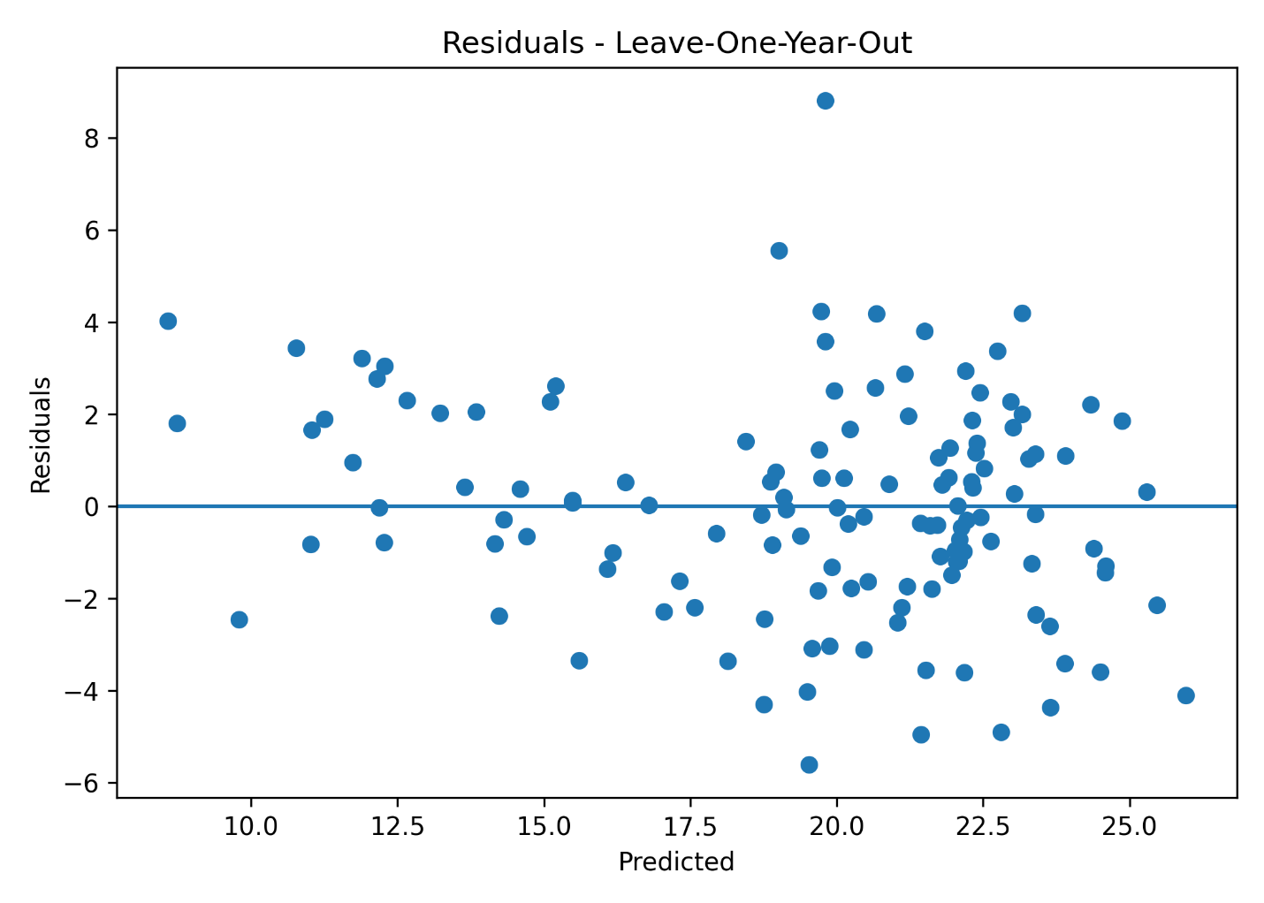Figure 10.7 presents residuals for the LOYO validation process. Residual analysis helps identify whether errors are randomly distributed or whether some years were harder to predict.

10.12 Overfitting Check
Overfitting occurs when a model performs very well on the training data but poorly on unseen data. This can happen when a model memorizes the data instead of learning general patterns.
In this project, overfitting was checked by comparing:
- In-sample Fixed Effects performance.
- Out-of-sample LOYO performance.
The overfitting check in the Python code compares the difference between in-sample R² and out-of-sample R², as well as the difference between in-sample RMSE and out-of-sample RMSE.
This validation step increased the reliability of the modeling process because it tested whether the model could generalize beyond the data used for training.

10.13 Residual Diagnostics
Residual diagnostics were used to evaluate regression model quality. A residual is the difference between the actual value and the predicted value:
Residual = Actual Value − Predicted Value
Residuals are important because they show the errors made by the model. A good regression model should have residuals that are randomly distributed around zero.
The project used:
- Jarque-Bera test.
- Breusch-Pagan test.
- Residual plots.
The Jarque-Bera test checks whether residuals follow a normal distribution. The Breusch-Pagan test checks for heteroskedasticity, which means that the variance of residuals is not constant across observations.
If heteroskedasticity exists, standard errors may be biased. For this reason, robust standard errors were used in the Pooled OLS model, and clustered standard errors were used in the Fixed Effects model.

10.14 Performance Measurements
The project used regression and clustering performance metrics. Since the main predictive task is regression, classification metrics such as Accuracy, Precision, Recall, F1-Score, ROC Curve, and Confusion Matrix are not directly applicable.
This is because unemployment rate is a continuous numeric variable, not a class label. Therefore, regression metrics are more appropriate.
  - Table 10.7: Performance Metrics Used
Metric | Type | Meaning
R² | Regression | Measures how much variance is explained by the model
Adjusted R² | Regression | Adjusts R² for number of predictors
RMSE | Regression | Measures average prediction error magnitude
MAE | Regression | Measures average absolute prediction error
Silhouette Score | Clustering | Measures cluster separation quality
Inertia | Clustering | Measures cluster compactness
Residual plots | Regression diagnostics | Shows prediction errors visually
If the project required classification, metrics such as Accuracy, Precision, Recall, F1-Score, ROC Curve, and Confusion Matrix would be appropriate. However, for this project, regression and clustering metrics are the correct evaluation tools.

11. Clustering and PCA Analysis

11.1 Introduction
Clustering was applied to identify groups of Jordanian governorates that share similar socioeconomic characteristics. Unlike regression, clustering does not predict a target variable. Instead, it groups observations according to similarity.
The goal of clustering in this project was to understand whether governorates can be grouped based on unemployment and related socioeconomic indicators.

11.2 Clustering Features
The clustering model used the following variables:
- Unemployment Rate.
- Establishments per 1,000 people aged 15 and above.
- Population Density.
- Students per Class.
- Schools per 1,000 population.
- Student Ratio 5–19.
These variables were selected because they represent labor market outcomes, economic activity, demographic pressure, and educational indicators.
Including unemployment rate in clustering is acceptable because clustering is unsupervised analysis. In this context, unemployment rate was used as one socioeconomic characteristic among others, not as a prediction target.

11.3 K-Means Clustering
K-Means clustering was used to classify governorates based on similarity. The algorithm assigns each governorate to a cluster by minimizing the distance between observations and cluster centers.
The K-Means algorithm works through the following steps:
- Select the number of clusters k.
- Initialize cluster centers.
- Assign each governorate to the nearest cluster center.
- Update cluster centers.
- Repeat until cluster assignments become stable.
In this project, different values of k were tested to determine the best number of clusters.

11.4 Elbow Method
The Elbow Method was used to help determine the optimal number of clusters. It evaluates the relationship between the number of clusters and inertia.
Inertia measures how close observations are to their cluster centers. Lower inertia means more compact clusters. However, increasing the number of clusters always reduces inertia, so the goal is to find the point where improvement begins to slow down.
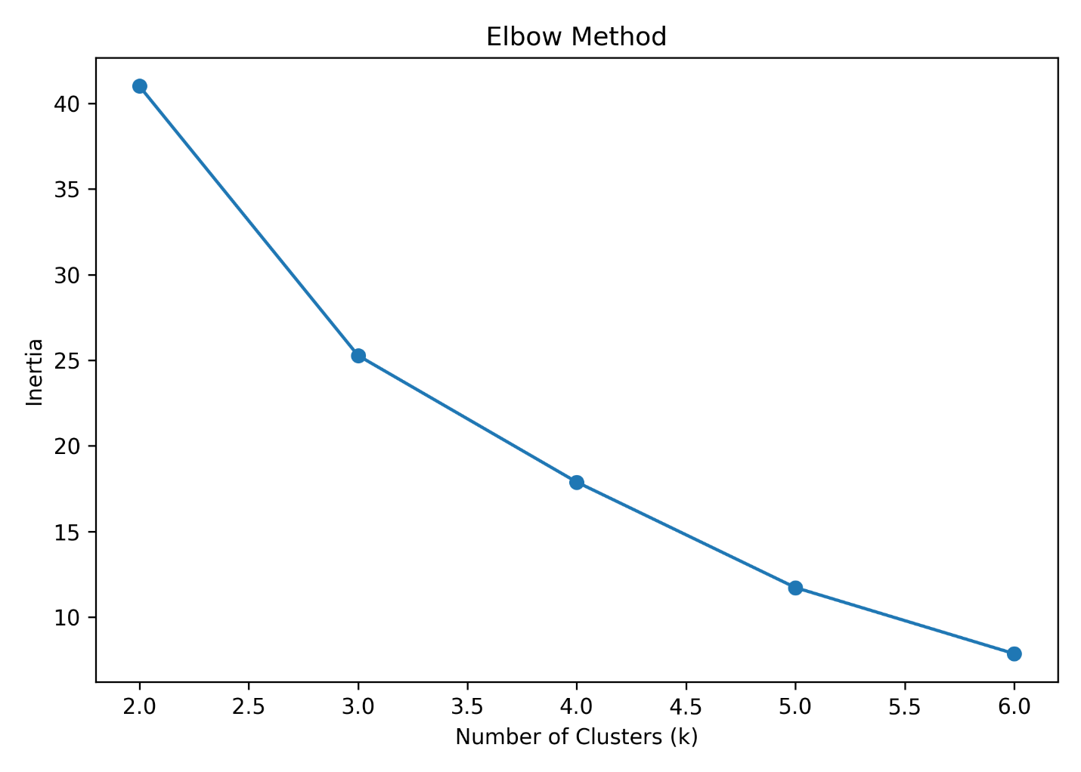
  - Figure 11.1: Elbow Method for K-Means Clustering

As shown in Figure 11.1, the elbow pattern supports selecting two clusters.

11.5 Silhouette Score
Silhouette Score was used as another method for validating the number of clusters. It measures how similar an observation is to its own cluster compared to other clusters.
The score ranges from -1 to 1.
Silhouette Score | Interpretation
Close to 1 | Strong clustering
Around 0 | Overlapping clusters
Negative | Possibly incorrect cluster assignment

  - Figure 11.2: Silhouette Scores for Cluster Validation
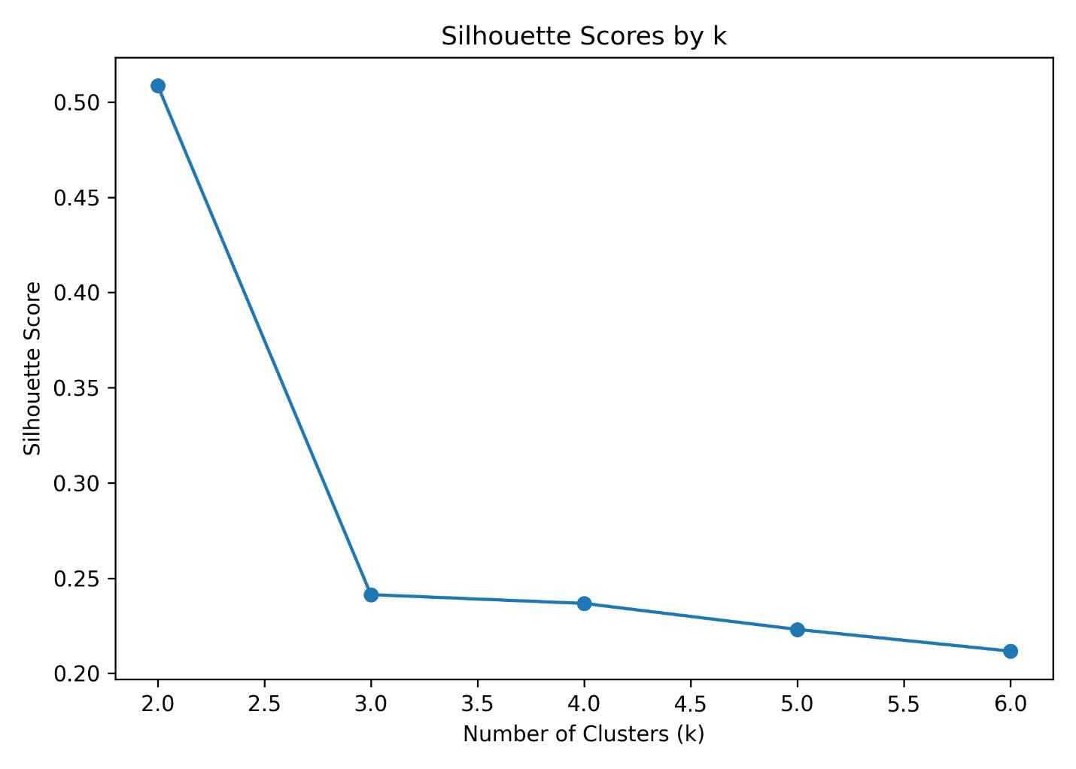The silhouette results supported the selection of k = 2 as the best number of clusters.

11.6 PCA Role in Clustering
Principal Component Analysis was applied before visualization. The clustering dataset contained several variables, which makes it difficult to visualize directly. PCA transformed the original variables into two principal components.
The PCA equation is:
PC1 = a1X1 + a2X2 + a3X3 + ... + anXn
Where:
Symbol | Meaning
PC1 | First principal component
X1, X2, X3 | Original variables
a1, a2, a3 | Weights assigned to variables
The weights are different because not all variables contribute equally to the variation in the dataset. PCA gives higher weights to variables that explain more variance.
PCA was used to reduce the clustering variables into two dimensions. This allowed governorates to be displayed clearly in a two-dimensional plot while preserving the most important information in the dataset.

11.7 PCA Cluster Visualization
After determining the best number of clusters, PCA was used to visualize the governorates in two dimensions.
  - Figure 11.3: Governorates Clusters Visualized Using PCA
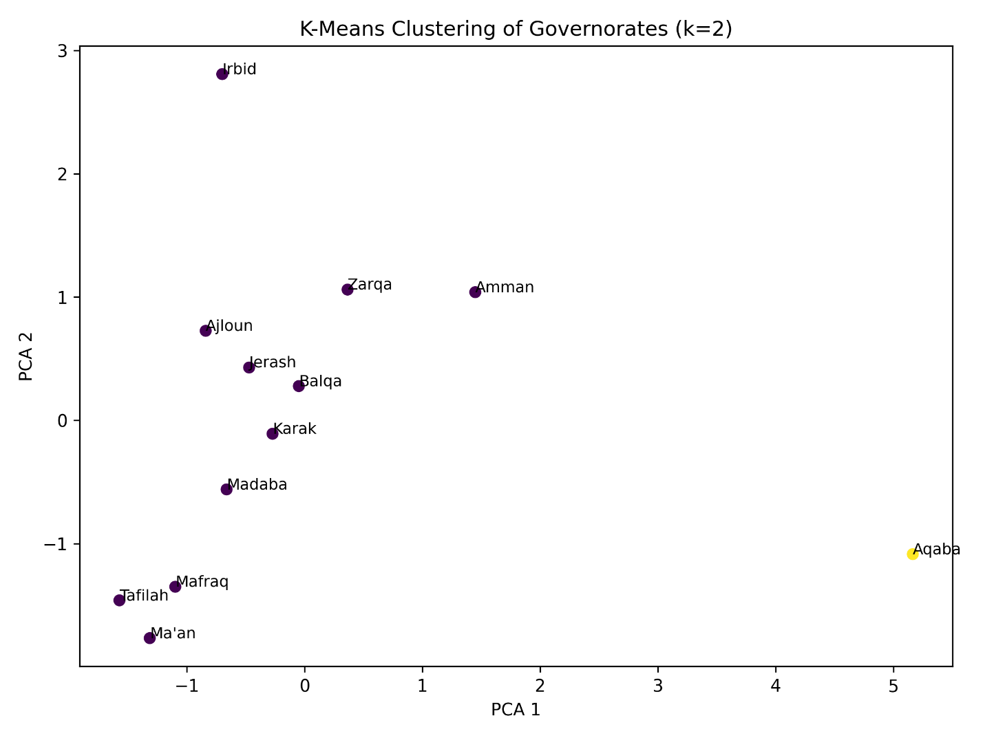
Figure 11.3 shows how governorates are grouped based on socioeconomic characteristics. Governorates that appear close to each other have similar profiles, while governorates that appear far from others are more different.
The PCA visualization showed that some governorates, such as Aqaba, appeared distinct from others. This may reflect different economic characteristics, investment patterns, tourism activity, or regional economic structure.

11.8 Hierarchical Clustering
Hierarchical Clustering was applied as a second clustering technique. Unlike K-Means, hierarchical clustering does not require selecting cluster centers at the beginning. It creates a tree-like structure called a dendrogram.
The project used Ward linkage, which minimizes within-cluster variance. This method is suitable for grouping governorates based on socioeconomic similarity.
  - Figure 11.4: Hierarchical Clustering Dendrogram
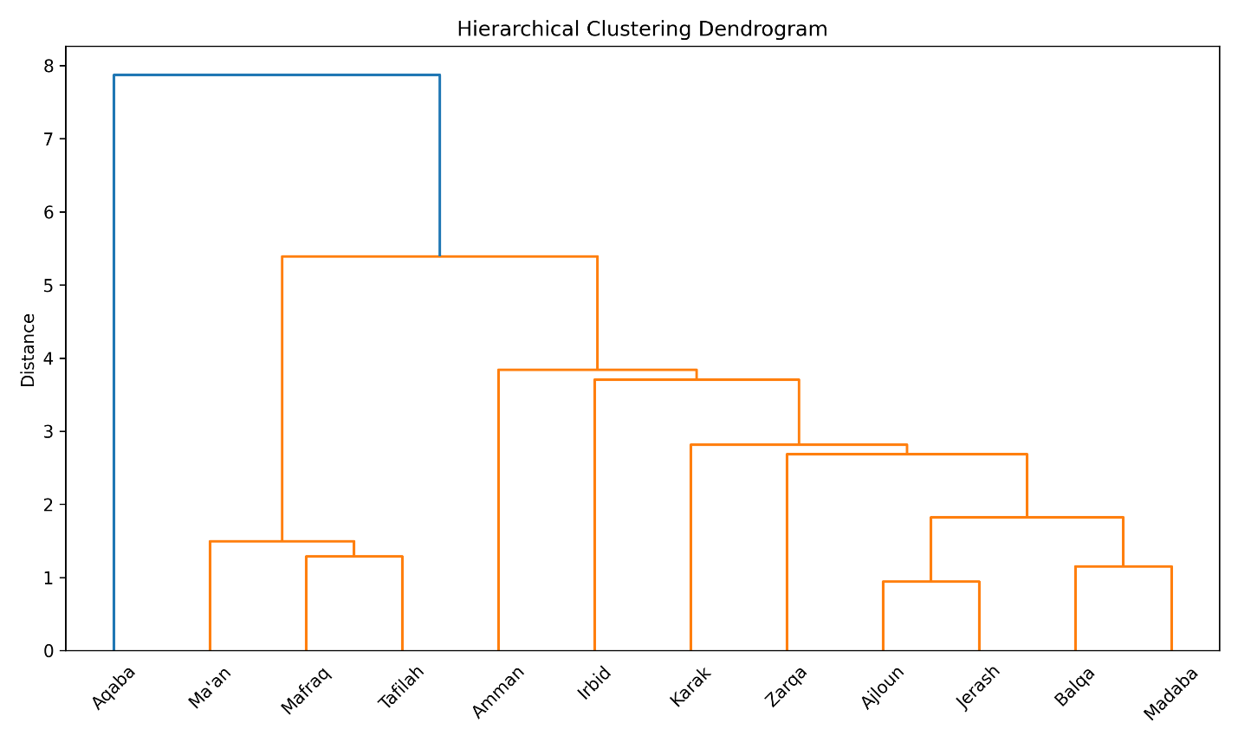
The dendrogram shows how governorates are connected based on similarity. Governorates joined at lower distances are more similar, while governorates joined at higher distances are more different.

11.9 Clustering Results Interpretation
The clustering analysis showed that Jordanian governorates can be grouped into two main socioeconomic patterns. This result was supported by both the Elbow Method and Silhouette Score.
The clustering results are important because they show that governorates do not all share the same unemployment-related characteristics. Some governorates may share similar economic and demographic profiles, while others may be distinct.
This supports the idea that unemployment policies should consider regional differences instead of applying one general policy to all governorates.

12. Tools Research and Selection Effort

12.1 Introduction
Tool selection is an important part of any Business Intelligence and data analytics project. The selected tools must support data collection, organization, cleaning, statistical modeling, machine learning, visualization, documentation, and project sharing. In this project, several tools were used together to build a complete data-driven workflow.
The main tools used were:
- Microsoft Excel.
- Python.
- Tableau.
- GitHub.
- Python libraries such as Pandas, NumPy, Statsmodels, Scikit-learn, Matplotlib, and SciPy.
Each tool was selected for a specific purpose. Excel was used to organize the dataset. Python was used for cleaning, modeling, validation, clustering, and generating outputs. Tableau was used to build interactive dashboards. GitHub is used to document and share the final project files.

12.2 Microsoft Excel
Microsoft Excel was used as the main environment for organizing the dataset before analysis. Since the data was collected from multiple official sources, Excel helped combine variables into one structured dataset.
Excel was used for:
- Organizing raw data.
- Combining data from different sources.
- Reviewing rows and columns.
- Creating derived indicators using formulas.
- Preparing the final dataset sheet.
- Checking values before importing the data into Python.
Excel was also used to calculate some derived variables. For example, for the years 2014 to 2016, actual population values by age group were not directly available, so population values were estimated using percentage rates and total population.
Example formula:
=Table3[@[Total Population]]*(Table3[@[population +15 Rate]]/100)
This formula was used to estimate the number of people aged 15 and above from total population and the available percentage rate.
Excel was useful in the early stages because it provided a simple and visible way to inspect the dataset and verify calculations before moving to Python.

12.3 Python
Python was the main analytical tool used in this project. It was selected because it provides powerful libraries for data cleaning, statistical modeling, machine learning, validation, diagnostics, and visualization.
Python was used for:
- Loading the Excel dataset.
- Renaming columns.
- Cleaning data.
- Converting data types.
- Handling missing values.
- Creating additional variables.
- Calculating descriptive statistics.
- Running VIF analysis.
- Building Pooled OLS regression.
- Building Fixed Effects regression.
- Applying Leave-One-Year-Out validation.
- Running residual diagnostics.
- Applying K-Means clustering.
- Applying Hierarchical Clustering.
- Applying PCA.
- Exporting figures and result files.
Python helped make the project reproducible. This means that the same code can be run again on the dataset to generate the same outputs, which improves the reliability of the project.

12.4 Pandas and NumPy
Pandas and NumPy were used for data manipulation and numerical processing.
Pandas was used for:
- Reading Excel files.
- Cleaning and transforming data.
- Filtering observations.
- Grouping data by governorate.
- Exporting Excel outputs.
- Creating model-ready datasets.
NumPy was used for numerical calculations such as square roots, arrays, and mathematical operations.
These libraries were essential because the dataset required several transformations before modeling.

12.5 Statsmodels
Statsmodels was selected for regression modeling because it provides detailed statistical outputs. Unlike general machine learning libraries that focus mainly on prediction, Statsmodels provides results that are important for academic interpretation.
Statsmodels was used for:
- Pooled OLS regression.
- Fixed Effects regression using categorical variables.
- Robust standard errors.
- Clustered standard errors.
- Regression coefficients.
- p-values.
- standard errors.
- confidence intervals.
- residual diagnostics.
This made Statsmodels suitable for the econometric and statistical modeling parts of the project.

12.6 Scikit-learn
Scikit-learn was used for machine learning and preprocessing tasks. It was selected because it provides reliable and widely used implementations of machine learning algorithms.
Scikit-learn was used for:
- StandardScaler.
- K-Means clustering.
- Silhouette Score.
- PCA.
- R².
- RMSE.
- MAE.
This library was important for the clustering, dimensionality reduction, and model evaluation parts of the project.

12.7 Matplotlib
Matplotlib was used to generate static charts and figures. These figures were exported as image files and inserted into the report and presentation.
Matplotlib was used to create:
- Actual vs predicted plots.
- Residual plots.
- Coefficient charts.
- Elbow Method plot.
- Silhouette Score plot.
- PCA clustering plot.
- Hierarchical dendrogram.
These charts provided visual evidence for model performance and clustering results.

12.8 Tableau
Tableau was used to create interactive Business Intelligence dashboards. It was selected because it provides strong visualization capabilities and allows users to interact with data through filters, maps, and charts.
Tableau was used to build two dashboards:
- Labor Market Overview Dashboard.
- Key Factors Affecting Unemployment Dashboard.
The dashboards helped communicate the results visually and made the findings easier to understand for non-technical users.

12.9 GitHub
GitHub should be used as the final repository for the project. It allows the project team to store and share the code, dataset, documentation, figures, screenshots, and instructions.
The GitHub repository should include:
  - Table 12.1: GitHub Repository Contents
Item | Description
Python code | Full data cleaning, modeling, clustering, and output generation code
Excel dataset | Final structured dataset, if sharing is allowed
Tableau workbook | Final Tableau dashboard file
Output figures | Regression, clustering, and validation images
Dashboard screenshots | Images of the two dashboards
README file | Project description and running instructions
Requirements file | Python libraries needed to run the project
Team information | Names of students and supervisor
GitHub Repository Link: [Insert GitHub Repository Link Here]

12.10 Tools Summary
  - Table 12.2: Tools and Their Roles
Tool | Role in the Project
Excel | Data organization and derived calculations
Python | Cleaning, modeling, validation, clustering, and outputs
Pandas | Data manipulation
NumPy | Numerical calculations
Statsmodels | Regression and diagnostics
Scikit-learn | PCA, clustering, scaling, and evaluation
Matplotlib | Figure generation
Tableau | Interactive dashboard development
GitHub | Project storage and documentation

13. Project Deployment Effort – Use Case
  - 13.1 Deployment Overview
The project can be deployed as a Business Intelligence solution that supports unemployment monitoring and labor market analysis in Jordan. The main output is an interactive Tableau dashboard supported by a Python-based analytical pipeline.
The deployment does not require a complex web application at the current stage. Instead, the project can be delivered through Tableau dashboards, a final report, GitHub repository, and scheduled analytical updates.
The project can be consumed by:
- Government institutions.
- Economic researchers.
- Labor market analysts.
- Educational planners.
- Policy makers.
- Academic users.

13.2 Main Use Case
The main use case is labor market monitoring for decision-makers. A user such as a policy analyst, researcher, or government employee can use the dashboard to understand unemployment trends and compare governorates.
For example, a decision-maker may ask:
- Which governorate has the highest unemployment rate?
- How has unemployment changed over time?
- Which socioeconomic factors are associated with unemployment?
- Are there groups of governorates with similar labor market conditions?
- Which model gives the best analytical explanation?
The dashboard and report together provide answers to these questions.

13.3 User Journey
A typical user journey would be:
- The user opens the Tableau dashboard.
- The user selects a specific year or governorate using filters.
- The dashboard updates automatically.
- The user reviews unemployment trends and geographic differences.
- The user opens the factor dashboard to understand possible determinants.
- The user refers to the report for statistical interpretation.
- The user uses the insights to support decisions or further research.
This workflow makes the project usable for both technical and non-technical users.

13.4 Deployment Options
The project can be deployed in several ways:
- Tableau Public
The dashboards can be published online for public access if the data is allowed to be shared.
- Tableau Server
The dashboards can be deployed internally inside an institution such as a ministry, university, or research center.
- Scheduled PDF Report
A monthly or yearly report can be generated from the dashboard and sent to decision-makers.
- GitHub Repository
The code and documentation can be stored in GitHub for reproducibility.
- Future Streamlit Web Application
A future version can include a simple web app where users upload updated data and receive predictions and dashboards.
At the current stage, Tableau dashboard deployment is the most suitable option because it supports interaction and visual exploration.

13.5 Project Flowchart
  - Figure 13.1: Project Flowchart
Start
↓
Collect Raw Data
↓
Prepare Excel Dataset
↓
Load Data in Python
↓
Clean and Transform Data
↓
Create Derived Indicators
↓
Select Features
↓
Run VIF Analysis
↓
Build Regression Models
↓
Evaluate Models
↓
Apply LOYO Validation
↓
Apply PCA and Clustering
↓
Generate Figures and Output Files
↓
Build Tableau Dashboards
↓
Interpret Results
↓
End
Use this flowchart in the report as a visual diagram. It can be drawn using SmartArt in Microsoft Word or PowerPoint.

13.6 System Block Diagram
  - Figure 13.2: System Block Diagram
Raw Data Sources
↓
Excel Dataset
↓
Python Processing Layer
↓
Statistical Modeling Layer
↓
Machine Learning Layer
↓
Generated Outputs
↓
Tableau Dashboard
↓
Final User / Decision Maker
The block diagram shows the main components of the project and how data moves from raw sources to final insights.

13.7 Deployment Benefits
Deploying this project provides several benefits:
- It allows users to monitor unemployment trends interactively.
- It supports comparison between governorates.
- It explains possible socioeconomic determinants.
- It provides statistical evidence through regression models.
- It groups governorates using clustering.
- It improves communication through dashboards.
- It supports data-driven decision-making.

14. Results

14.1 Introduction
This section presents the final results of the project. The results include regression performance, validation outcomes, clustering findings, dashboard insights, and overall interpretation.
The project successfully produced both analytical and visual outputs. The analytical outputs were generated using Python, while the visual outputs were presented through Tableau dashboards and model figures.

14.2 Model Comparison Results
The project compared three main regression-related outputs:
- Pooled OLS.
- Fixed Effects.
- Leave-One-Year-Out validation.
  - Table 14.1: Model Performance Comparison
Model | R² | RMSE | MAE | Interpretation
Pooled OLS | 0.281 | 3.586 | 2.955 | Baseline model with limited explanatory power
Fixed Effects | 0.847 | 1.657 | 1.306 | Strongest in-sample model
Leave-One-Year-Out | 0.692 | [Insert LOYO RMSE] | [Insert LOYO MAE] | Tests temporal generalization
The Fixed Effects model achieved the best performance. This result confirms that governorate-specific differences are important in unemployment analysis.

14.3 Pooled OLS Results
The Pooled OLS model provided a useful baseline. However, its R² value was lower than the Fixed Effects model. This means that Pooled OLS explained a smaller percentage of unemployment variation.
The main limitation of Pooled OLS is that it does not control for governorate-specific characteristics. For example, Aqaba may have different economic activities compared to Mafraq or Tafila. Pooled OLS does not fully capture these structural differences.
Therefore, Pooled OLS was useful for comparison, but it was not the final preferred model.

14.4 Fixed Effects Results
The Fixed Effects model achieved R² = 0.847, RMSE = 1.657, and MAE = 1.306. These values indicate strong explanatory and predictive performance.
The improvement occurred because Fixed Effects controls for unobserved governorate-specific factors. This is very important in Jordan because governorates differ in population, infrastructure, investment, job opportunities, education, and geography.
The Fixed Effects model is therefore the most suitable model for this project.

14.5 LOYO Validation Results
Leave-One-Year-Out validation was used to test how well the model performs on unseen years. This validation method is important because it evaluates temporal generalization.
If the model performs well under LOYO validation, it means that it can predict unemployment patterns for years that were not included in training. If performance decreases in some years, this may indicate that those years had unusual economic conditions.
The overall LOYO R² was 0.692, which shows acceptable predictive performance across unseen years. This result indicates that the model was not only fitting the training data but also generalizing reasonably across time.
Some yearly variation remained because unemployment is affected by external economic and social conditions that may differ from year to year.

14.6 Clustering Results
The clustering analysis selected two clusters as the best grouping structure. This decision was supported by both Elbow Method and Silhouette Score.
The clustering results show that Jordanian governorates can be grouped according to socioeconomic similarity. This is important because it suggests that some governorates share similar labor market characteristics.
Aqaba appeared as a distinct governorate in the clustering results. This may be due to its unique economic structure, tourism activity, port-related activity, and investment environment.

14.7 Dashboard Results
The Tableau dashboards successfully presented the project findings visually.
The Labor Market Overview dashboard helped answer the question: what is happening in Jordan’s labor market? It showed unemployment trends, governorate differences, and geographic distribution.
The Key Factors Affecting Unemployment dashboard helped answer the question: why is unemployment happening? It connected unemployment with socioeconomic variables such as population density, establishments, and schools.
The dashboards made the analysis easier to understand for non-technical users.

14.8 Key Findings
The main findings from the project are:
- Unemployment patterns differ significantly between Jordanian governorates.
- Fixed Effects regression is more suitable than Pooled OLS for this panel dataset.
- Governorate-specific characteristics are important in explaining unemployment.
- Economic establishments are important indicators of economic activity.
- Population density may reflect pressure on the labor market.
- Educational infrastructure may be related to labor market outcomes.
- Clustering reveals regional socioeconomic similarities.
- PCA improves the visualization of multidimensional clustering results.
- Tableau dashboards improve communication and decision support.

14.9 Did the Project Achieve Its Objectives?
Yes, the project achieved its objectives. It collected and prepared relevant unemployment-related data, built regression models, applied validation, performed clustering, created dashboards, and produced meaningful insights.
The project also met the main requirements of a Business Intelligence graduation project because it included:
- Data acquisition.
- Data cleaning.
- Data understanding.
- Visualization.
- Advanced analytics.
- Modeling.
- Evaluation.
- Dashboard design.
- Results interpretation.

15. Conclusion and Recommendations

15.1 Conclusion
This graduation project presented a comprehensive data-driven analysis of unemployment in Jordan and its socioeconomic determinants between 2014 and 2024. The project combined Business Intelligence, statistical modeling, machine learning, and visualization to analyze a real economic problem.
The use of panel data allowed the project to study unemployment across both governorates and years. This structure was important because unemployment is not only a time-based issue but also a regional issue. Governorates in Jordan differ in population, economic activity, education, infrastructure, and labor market conditions.
The Pooled OLS model provided a useful baseline, but it had limited explanatory power. The Fixed Effects model performed significantly better because it controlled for governorate-specific characteristics. This result confirmed that regional characteristics are essential when analyzing unemployment.
Leave-One-Year-Out validation added strength to the project by testing temporal generalization. Clustering analysis provided another perspective by grouping governorates according to socioeconomic similarity. PCA made clustering results easier to visualize and interpret.
The Tableau dashboards successfully transformed technical results into interactive visual insights. The first dashboard explained what is happening in the labor market, while the second dashboard explained why unemployment may be happening.
Overall, the project shows that data analytics and Business Intelligence can support labor market analysis and help decision-makers understand unemployment more clearly.

15.2 Recommendations
Based on the project findings, the following recommendations are suggested:
- Labor market policies should consider governorate-specific differences.
- Governorates with high unemployment should receive targeted economic development programs.
- Economic establishments should be encouraged in regions with limited job opportunities.
- Educational planning should be connected more strongly with labor market demand.
- Government institutions should use dashboards for continuous labor market monitoring.
- Future datasets should include more detailed variables such as wages, sector employment, gender unemployment, youth unemployment, and investment indicators.
- Clustering results can be used to design regional policy groups instead of applying one national policy to all governorates.
- Predictive analytics should be integrated into economic planning departments.

15.3 How the Situation Can Be Improved
The results of this study suggest that unemployment in Jordan should not be treated as one uniform national issue. Instead, each governorate should be analyzed according to its own socioeconomic conditions.
Possible improvement actions include:
- Encouraging investment in high-unemployment governorates.
- Supporting small and medium enterprises outside the capital.
- Creating training programs based on local labor market needs.
- Connecting education outputs with employment opportunities.
- Expanding vocational and technical education.
- Using data dashboards to continuously monitor unemployment.
- Designing employment policies based on regional clusters.
These solutions can help decision-makers create more targeted and effective unemployment reduction strategies.

15.4 Value of the Study
This study transformed raw unemployment-related data into meaningful insights. It showed that data analysis can reveal patterns that are difficult to identify through simple observation.
The project provided value by:
- Organizing unemployment-related data into a structured panel dataset.
- Identifying important socioeconomic indicators.
- Comparing regression models.
- Showing the importance of governorate-specific effects.
- Grouping governorates based on socioeconomic similarity.
- Creating dashboards for interactive analysis.
- Supporting evidence-based decision-making.
The study demonstrates that data-driven analysis can help transform unemployment from a general national issue into a clearer regional problem that can be understood, monitored, and addressed with targeted solutions.

15.5 Future Work
Future work can improve this project in several ways:
- Add more recent data when available.
- Include sector-level employment data.
- Build forecasting models for future unemployment rates.
- Use deep learning models if a larger dataset becomes available.
- Add GIS-based spatial analysis.
- Build a Streamlit web application.
- Connect Tableau dashboards to live data sources.
- Include more macroeconomic variables such as GDP, inflation, wages, and investment.
- Analyze unemployment by gender and age groups.
- Compare Jordan with other countries in the region.

16. References
Jordan Department of Statistics. Official statistical publications and labor market indicators.
Social Security Corporation. Establishments and labor market-related administrative data.
Ministry of Education. Education statistics and school-related indicators.
Scikit-learn Documentation. Machine learning tools, clustering algorithms, PCA, and evaluation metrics.
Statsmodels Documentation. Regression modeling, robust standard errors, and statistical diagnostics.
Tableau Documentation. Business Intelligence dashboards and data visualization tools.
Pandas Documentation. Data manipulation and analysis in Python.
NumPy Documentation. Numerical computing in Python.
Matplotlib Documentation. Data visualization in Python.
Wooldridge, J. M. Introductory Econometrics: A Modern Approach.
Gujarati, D. N., & Porter, D. C. Basic Econometrics.
James, G., Witten, D., Hastie, T., & Tibshirani, R. An Introduction to Statistical Learning.
Han, J., Kamber, M., & Pei, J. Data Mining: Concepts and Techniques.

17. Appendices

Appendix A: Important Python Code Sections

A.1 Importing Libraries
import os
import warnings
import numpy as np
import pandas as pd
import matplotlib.pyplot as plt
import statsmodels.api as sm
import statsmodels.formula.api as smf

from sklearn.metrics import r2_score, mean_squared_error, mean_absolute_error
from sklearn.preprocessing import StandardScaler
from sklearn.cluster import KMeans
from sklearn.metrics import silhouette_score
from sklearn.decomposition import PCA
from scipy.cluster.hierarchy import linkage, dendrogram
from statsmodels.stats.outliers_influence import variance_inflation_factor
from statsmodels.stats.diagnostic import het_breuschpagan
from statsmodels.stats.stattools import jarque_bera
This section imports the libraries required for data manipulation, modeling, validation, diagnostics, clustering, dimensionality reduction, and visualization.

A.2 Project Settings
FILE_PATH = "GRADUATION.xlsx"
SHEET_NAME = "Final Data"
OUTPUT_DIR = "FINAL_PROJECT_OUTPUTS_IMPROVED"
TARGET = "Unemployment_Rate"
This code defines the input file, sheet name, output directory, and target variable.

A.3 Regression Features
BASE_FEATURES = [
"Establishments_per_1000_15plus",
"Population_Density",
"Schools_per_1000_population"
]
These variables were selected as the main explanatory variables for regression modeling.

A.4 Clustering Features
CLUSTER_FEATURES = [
"Unemployment_Rate",
"Establishments_per_1000_15plus",
"Population_Density",
"Students_per_Class",
"Schools_per_1000_population",
"Student_Ratio_5_19"
]
These variables were used to group governorates according to socioeconomic similarity.

A.5 RMSE Function
def rmse(y_true, y_pred):
return np.sqrt(mean_squared_error(y_true, y_pred))
This function calculates Root Mean Squared Error, which measures average prediction error magnitude.

A.6 Model Summary Function
def summarize_predictions(y_true, y_pred, label):
return {
"Model": label,
"R2": r2_score(y_true, y_pred),
"RMSE": rmse(y_true, y_pred),
"MAE": mean_absolute_error(y_true, y_pred)
}
This function calculates the main regression performance metrics.

A.7 VIF Function
def compute_vif(df, features):
X = df[features].copy()
X = sm.add_constant(X)
out = pd.DataFrame()
out["Variable"] = X.columns
out["VIF"] = [variance_inflation_factor(X.values, i) for i in range(X.shape[1])]
return out
This function calculates Variance Inflation Factor for each independent variable.

A.8 Loading and Cleaning Data
df = pd.read_excel(FILE_PATH, sheet_name=SHEET_NAME)
df = df.rename(columns=rename_map).copy()
df["Governorate"] = df["Governorate"].astype(str).str.strip()
df["Year"] = pd.to_numeric(df["Year"], errors="coerce")
This code loads the Excel dataset, renames columns, cleans governorate names, and converts the year column into numeric format.

A.9 Handling Missing Values
df = df.dropna(subset=["Governorate", "Year", TARGET] + BASE_FEATURES).reset_index(drop=True)
This code removes rows with missing values in essential columns required for modeling.

A.10 Creating Year Squared
df["Year_Squared"] = df["Year"] ** 2
This creates a quadratic time trend variable to capture nonlinear time effects.

A.11 Pooled OLS Model
pooled_formula = f"{TARGET} ~ " + " + ".join(BASE_FEATURES)
pooled_model = smf.ols(pooled_formula, data=df).fit(cov_type="HC3")
This code builds the Pooled OLS model using robust standard errors.

A.12 Fixed Effects Model
fe_formula_in_sample = (
f"{TARGET} ~ " +
" + ".join(BASE_FEATURES) +
" + C(Governorate) + C(Year)"
)

fe_model = smf.ols(fe_formula_in_sample, data=df).fit(
cov_type="cluster",
cov_kwds={"groups": df["Governorate"]}
)
This code builds the Fixed Effects model by including governorate and year effects. Clustered standard errors are used by governorate.

A.13 LOYO Validation
for test_year in years:
train_df = df[df["Year"] != test_year].copy()
test_df = df[df["Year"] == test_year].copy()
This loop removes one year at a time from training and uses it for testing.

A.14 K-Means Clustering
final_kmeans = KMeans(n_clusters=best_k, random_state=42, n_init=10)
cluster_df["Cluster"] = final_kmeans.fit_predict(X_cluster)
This code applies K-Means clustering using the best number of clusters.

A.15 PCA
pca = PCA(n_components=2)
X_pca = pca.fit_transform(X_cluster)
This code reduces the clustering features into two principal components for visualization.

A.16 Hierarchical Clustering
linked = linkage(X_cluster, method="ward")
dendrogram(
linked,
labels=cluster_df["Governorate"].tolist(),
leaf_rotation=45,
leaf_font_size=10,
ax=ax
)
This code creates the hierarchical clustering dendrogram.

Closing Statement
This project was not only an analytical study of unemployment rates, but also an attempt to transform raw socioeconomic data into meaningful insights that can support better understanding and decision-making. By combining Business Intelligence, statistical modeling, and machine learning techniques, the project showed how data can be used to reveal regional differences, explain unemployment patterns, and support more targeted solutions.
The findings emphasize that unemployment in Jordan should not be viewed as one general national issue only, but as a regional challenge that differs from one governorate to another. Therefore, data-driven analysis can play an important role in helping decision-makers identify where the problem is concentrated, understand the factors behind it, and design more effective policies for the future.

